|  |  |
| --- | --- |
| A picture of a winding road and trees  js – oops, dom, Async | Shikhin Misra |

Contents

Object Literals 2

Updating Properties 4

Classes 6

Class Methods 7

Method Chaining 9

Class Inheritance 11

Constructors (under the hood) 14

Prototype 15

Prototype Inheritance 18

DOM Introduction 19

Query Selector – Querying the DOM 21

Query Selector All 24

Getting element by ID 25

Getting elements by Class Name 26

Getting element by Tag Name 27

Changing text inside element 27

Changing HTML inside element 29

Getting and setting attribute of element 31

Adding and removing class 31

Challenge 31

Toggling class 31

What is Async JavaScript 32

HTTP Requests 35

Status Codes 42

Callback Functions 45

Using JSON Data 47

Callback Hell 49

Promises 49

Chaining Promises 49

The Fetch API 49

Async & Await 49

Throwing Errors 49

# Object Literals

Suppose we need to create few users with some characteristic (properties) and functions. We can do it by creating a lot of users as below, or we can club all these properties and functions into a single type which is called an **Object**.

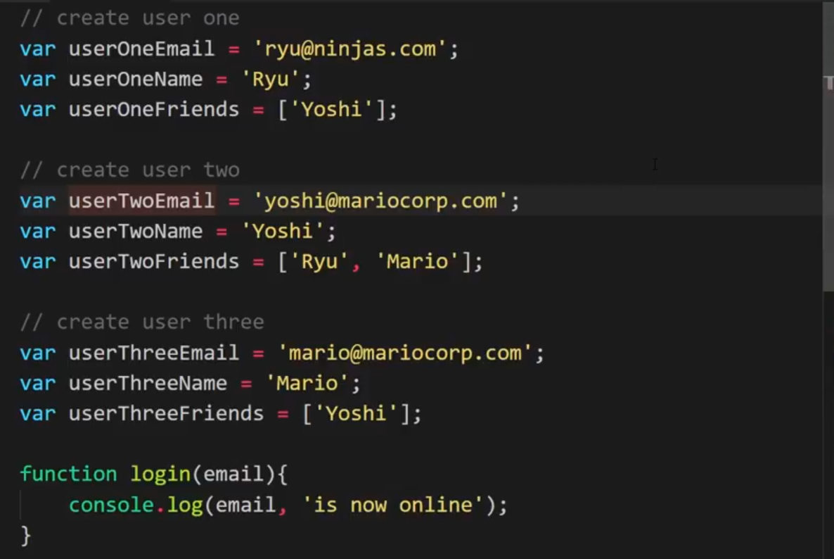

Below, we have created an object userOne and clubbed all the properties and functions together. Note that the function is now kind of a property specific to userOne instead of a standalone function. This type of function is called a method.

The thing to note here is that here we are creating an object userOne for a single user. Later, we will create a “Class” so that it can be used to create a lot of objects like userOne, userTwo, userThree and so on.

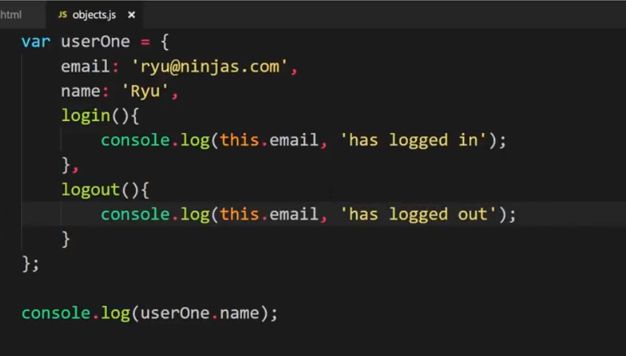

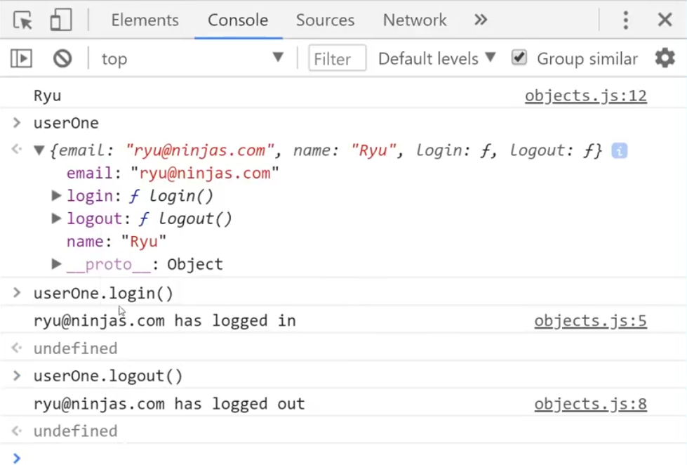

# Updating Properties

Now we will modify the properties of the object.

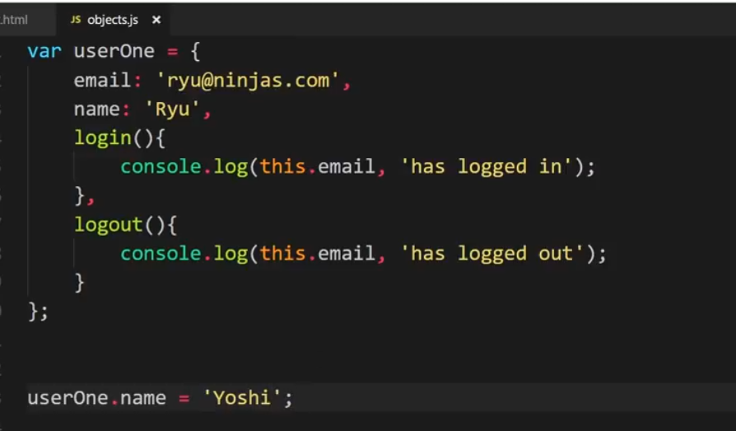

Checking this object in console.



Now, from the console we will change the name property again and then check for the object.

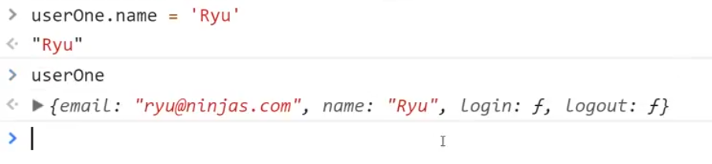

Below, we are adding few more properties to the object i.e. age and logInfo. However, this way of adding properties is certainly not a good practice.

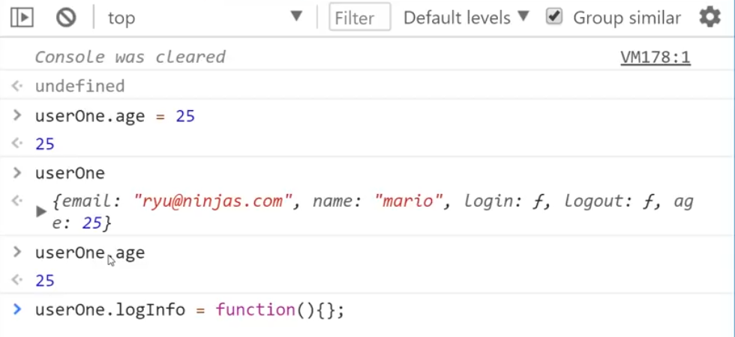

As we can see, we can change the properties of an object but it is still the same object. If we have to create multiple objects having similar behaviour, we have to create a class. Otherwise, like below 😊

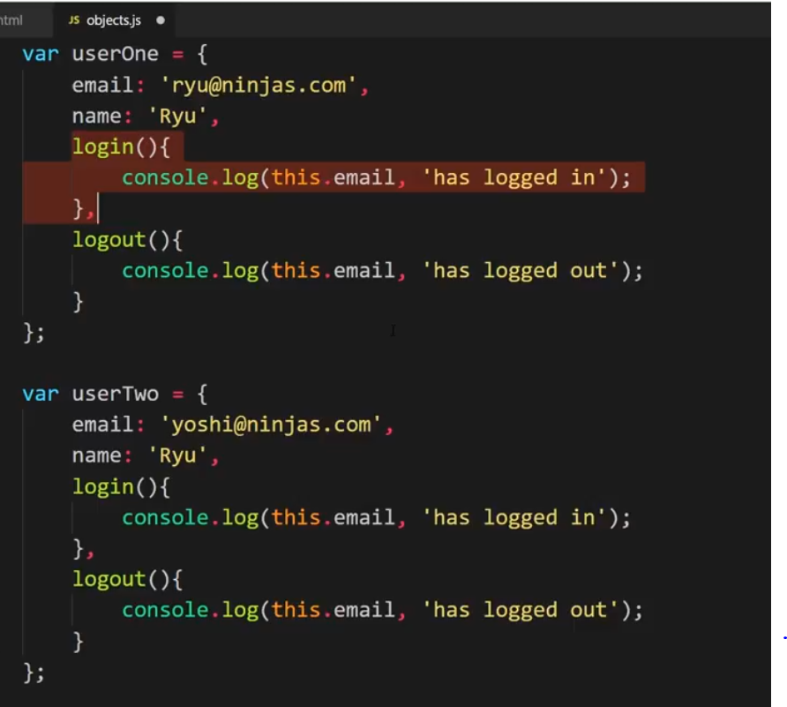

# Classes

Classes are not an inherent feature of JavaScript. It is just a kind of wrapper of the prototype model in JavaScript. We will look into the prototype model later.

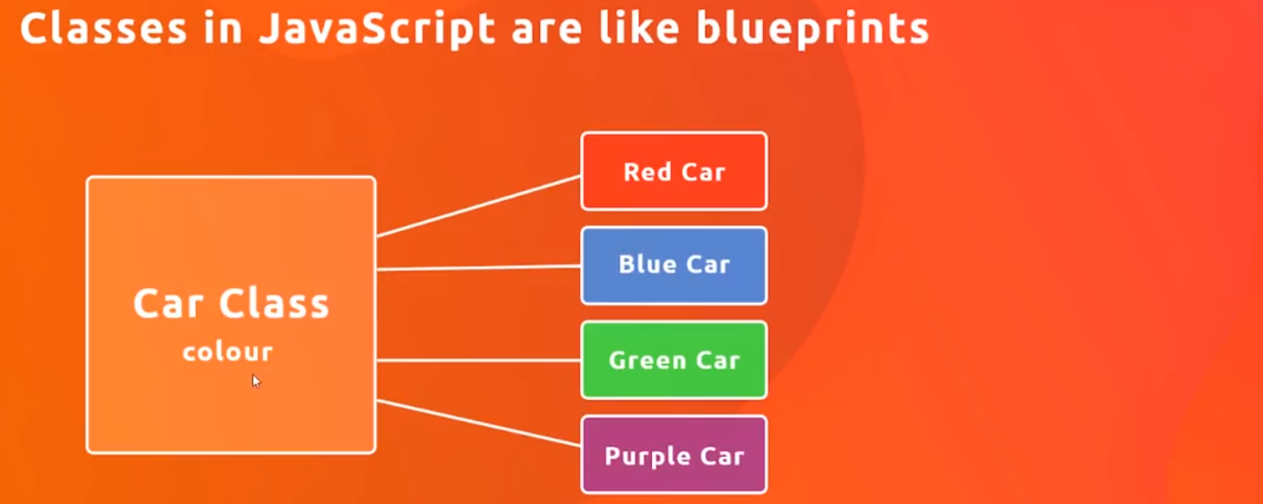

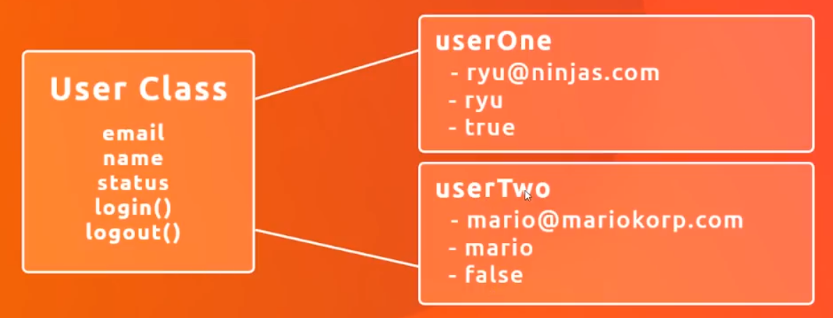

To create a new user object of a class, we need a constructor function. Whenever we need to create a new user, we invoke the constructor function.

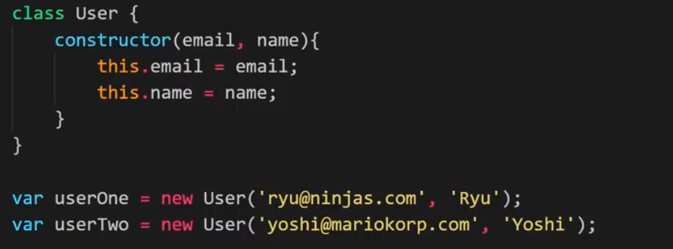

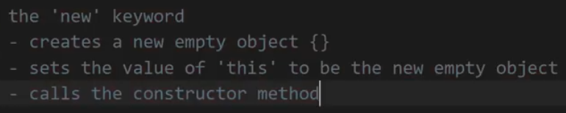

# Class Methods

Below we have created 2 functions – login() and logout() in our User class.

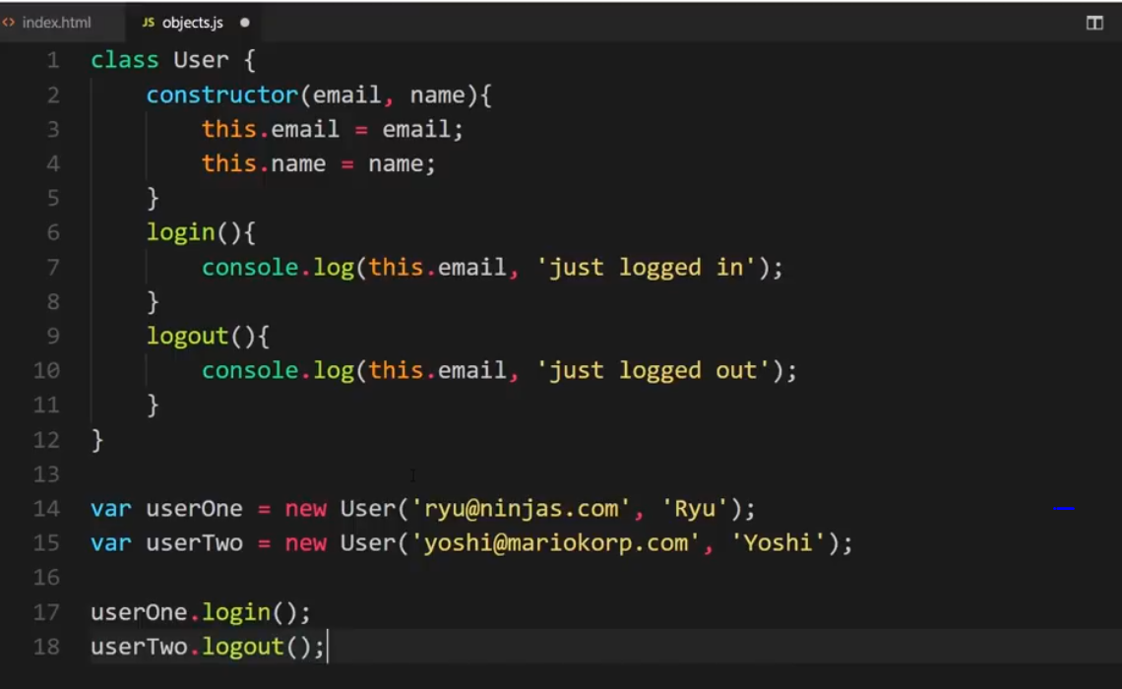

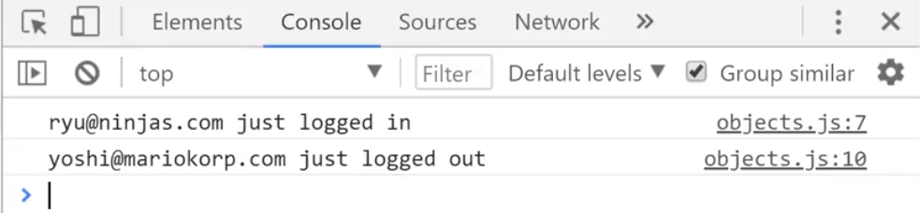

If we check for the **userOne** and **userTwo** objects in the console, we can see the properties and methods for those objects.

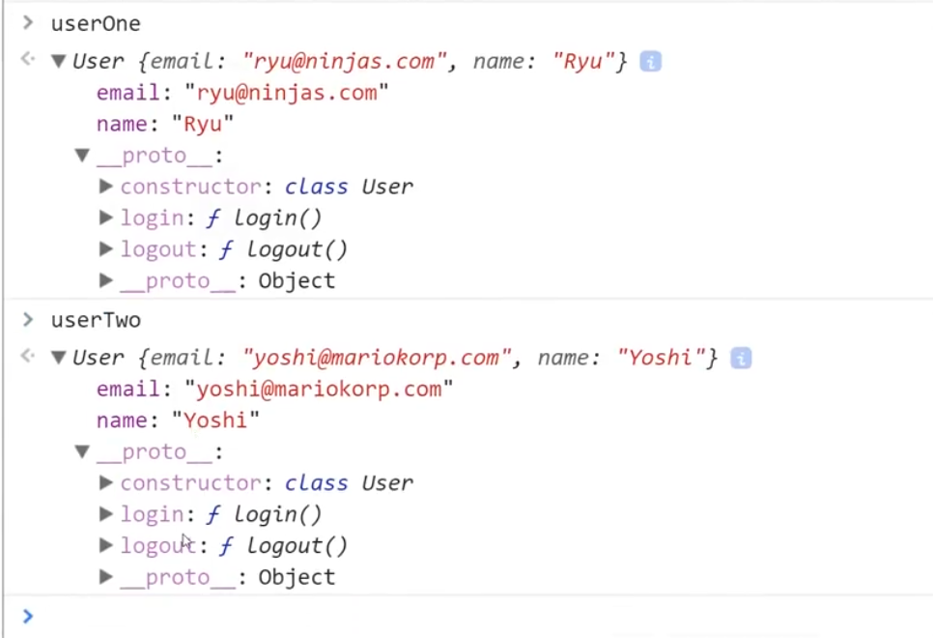

# Method Chaining

We can have several methods chained together in JavaScript. This is called method chaining.

Below method chaining code gives us an exception. The reason for that is that “userOne.login()” returns back **undefined**. And so logout() given an exception.

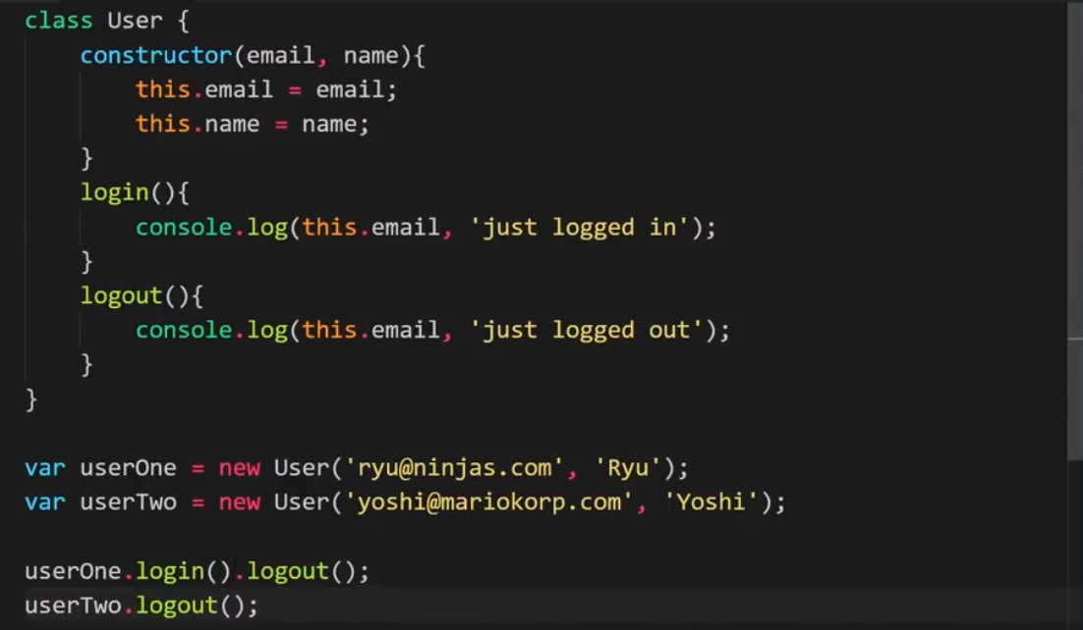

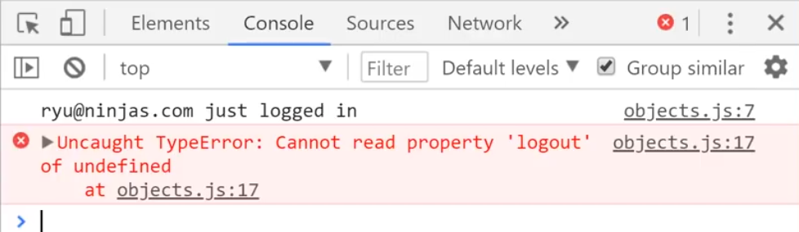

To demonstrate method chaining we will create a new method which will return some object so that the chained method does not give an exception. In the below code, updateScore() will add 1 to the count and return back the object. The chained methods (another updateScore() and then logout()) do not return and exception since they are now acting upon the User object.

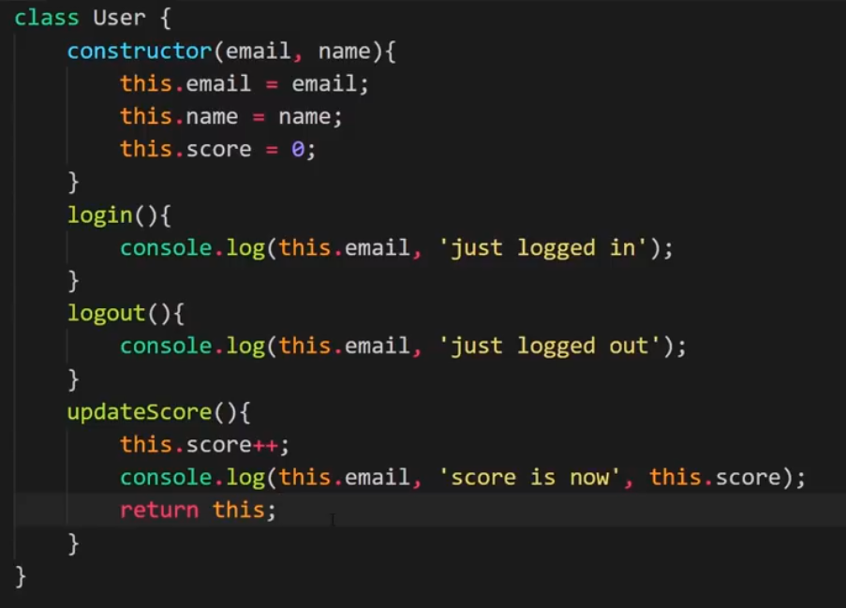

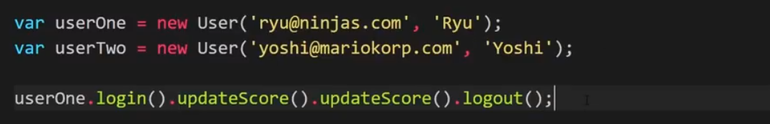

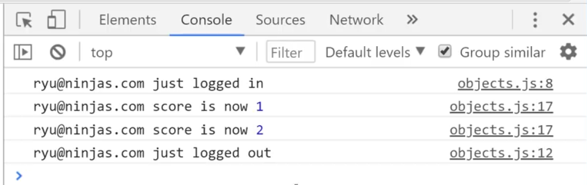

# Class Inheritance

We will now create a special type of users called Admins. These will have all the properties of the regular users but have more functionality like delete users etc.

We can create a new class with all the properties of the User class + additional functionality. However, we will use class inheritance to active our objective. For this we will create a new class **Admin** and then inherit from the **User** class.

We haven’t created a constructor for class Admin. Admin will inherit the constructor of the User class. The deleteUser(user) function compares the email address of the passed in User with the entire array of users and if it finds a match, it deletes that user.

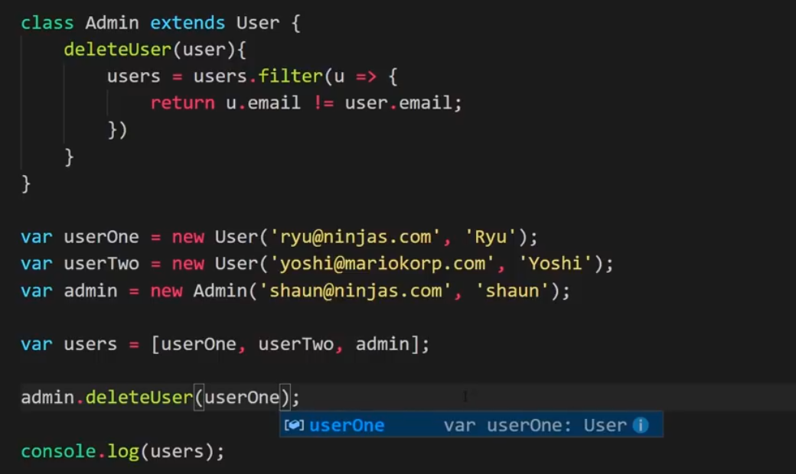

We can see that userOne is removed.

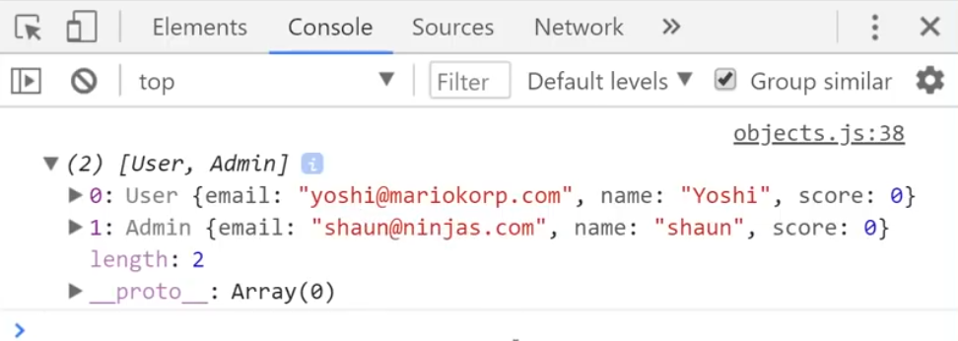

When we check for the user Admin, we see under **_proto_** that we have inherited 3 functions.

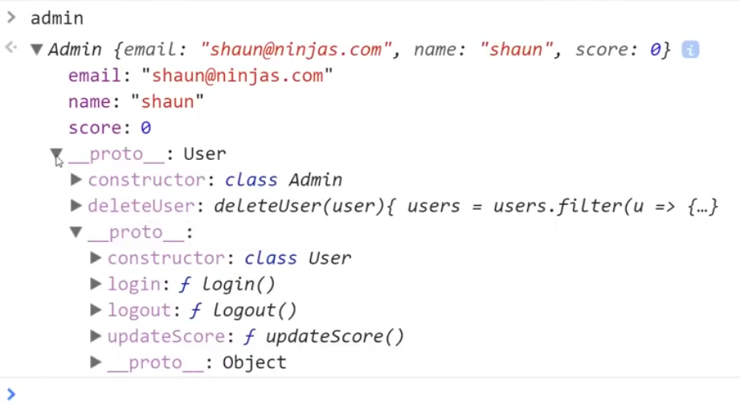

If we try to run delete functionality on userOne which is not an admin, the function will return an exception when it runs.

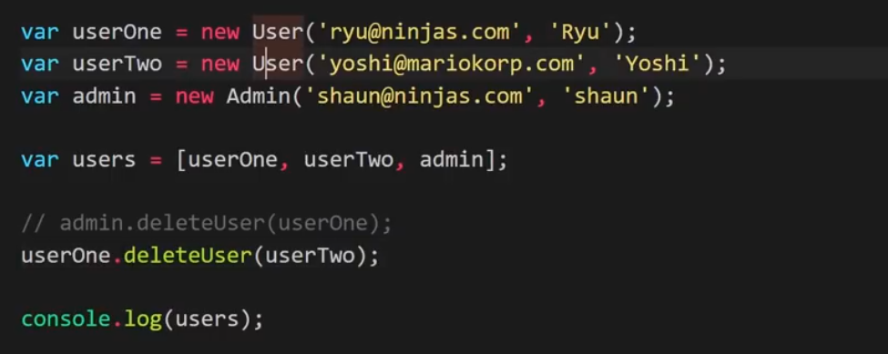

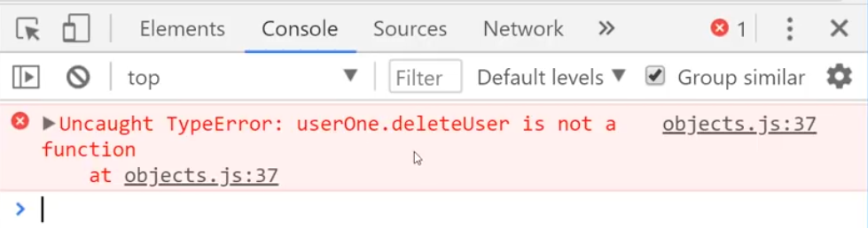

# Constructors (under the hood)

Below code shows how things were done before Classes were introduced in JavaScript.

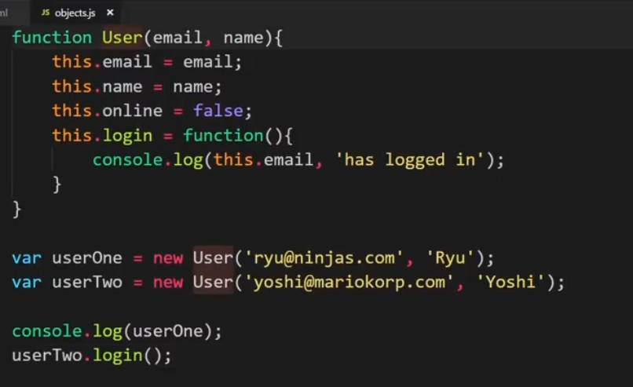

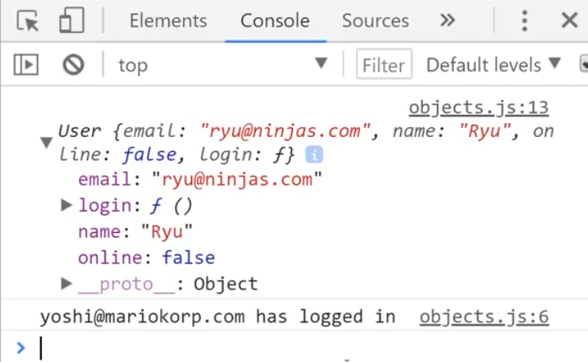

# Prototype

When we define an object, we get a lot of functions that can be used on that object defined under __proto__. For e.g. we have an array and when we check that in console we see all the functions.

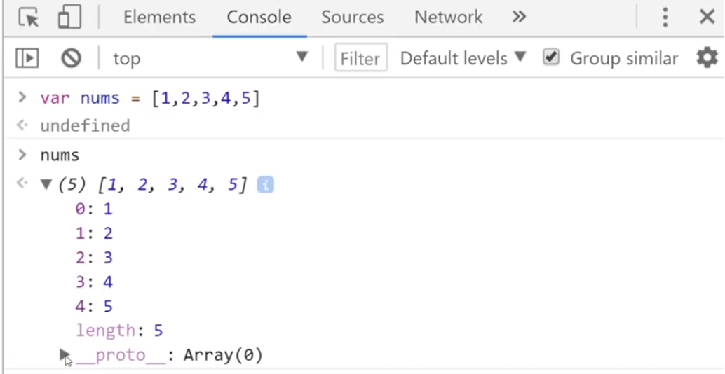

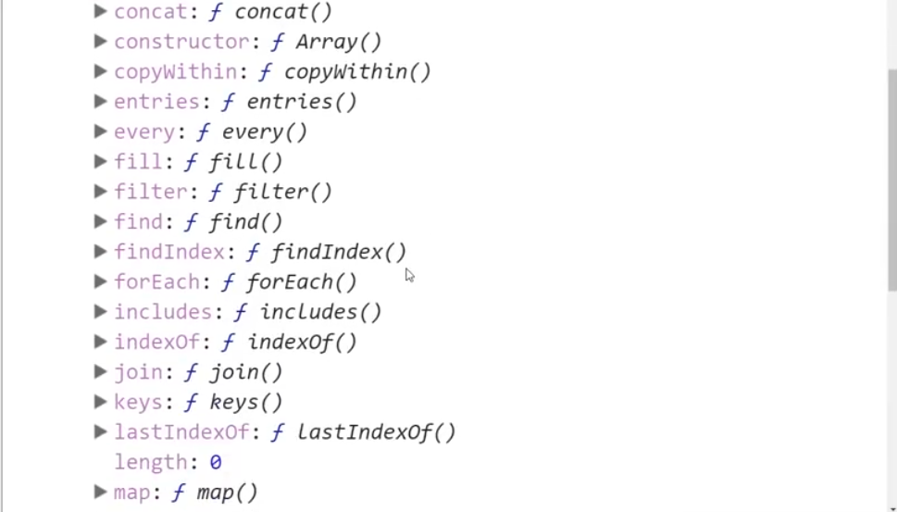

If we have to use the sort () method, we do not write nums.__proto__.sort(). JavaScript proxies every function inside __proto__ to be used directly like nums.sort()

If we check userOne object, it is shown as below. As you can see, the login() function is not under __proto__ but directly under the object. When we had created a Class, the methods defined in it were under __proto__.

This is because we had defined the login() function directly in the constructor.

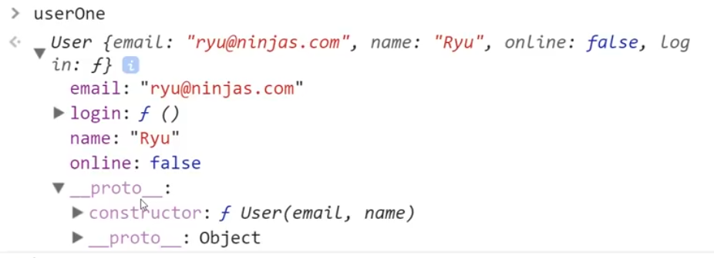

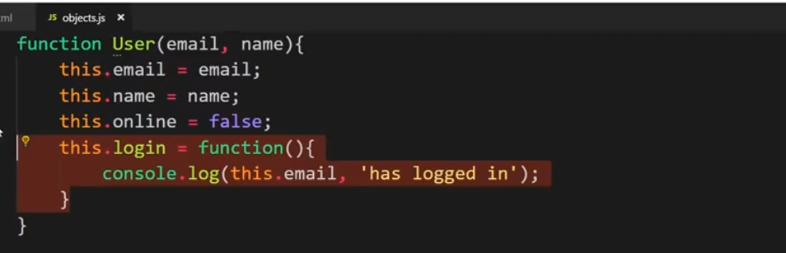

Any object that we have in JavaScript has a prototype. An array, a Date, a custom object, User object etc all have a prototype.

In our User object, we have functions login() and logout() defined as prototypes. Any user created from this prototype will have these two functions defined in their __proto__ property.

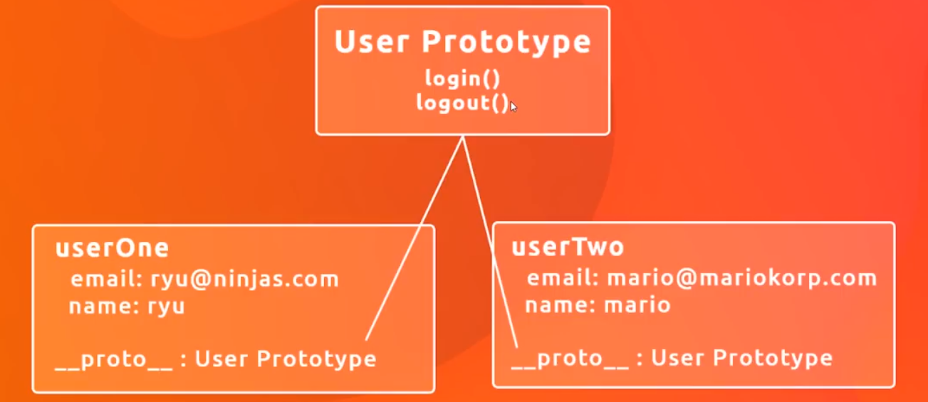

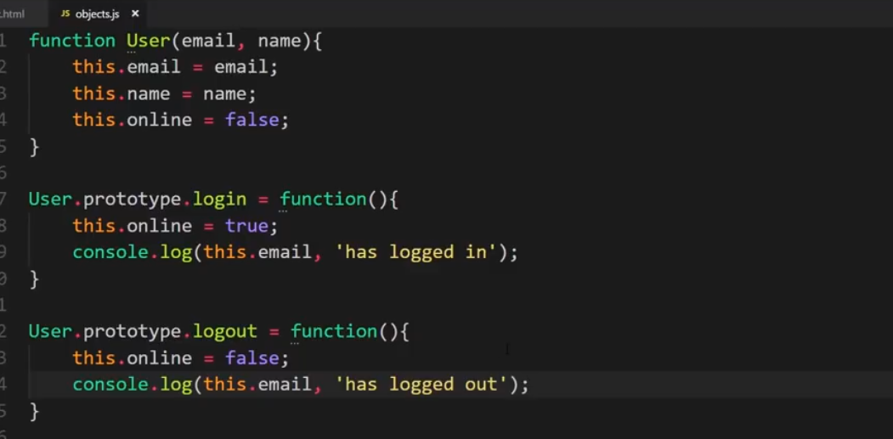

And we can see that both the functions are working as expected.

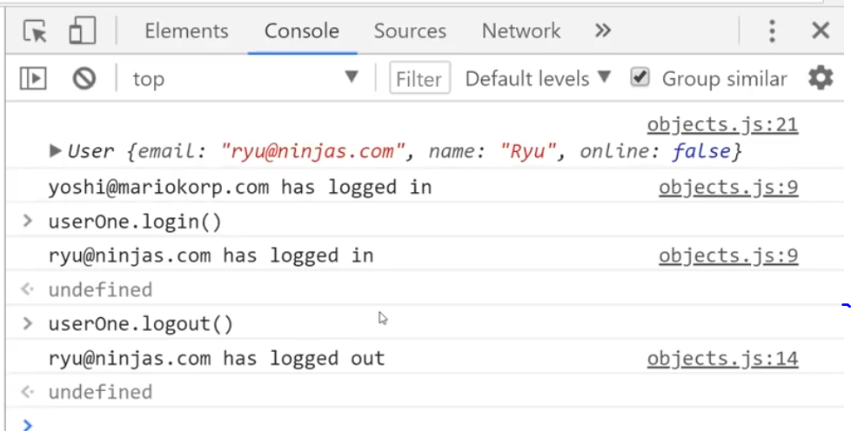

When we check userOne object, we can find the functions under __proto__.

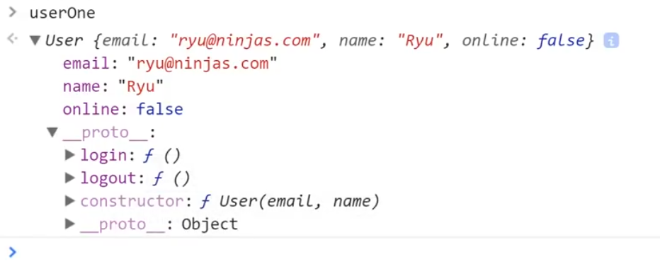

# Prototype Inheritance

# DOM Introduction

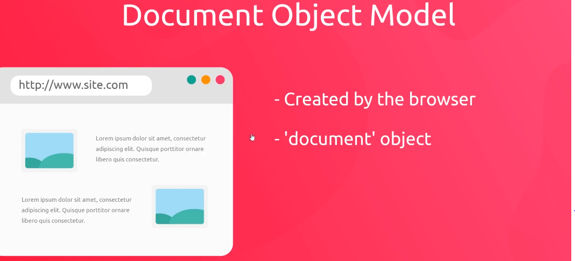

A DOM is created by the browser when an HTML document loads inside it. It contains many different properties and methods to interact with the HTML document.

Below, we have opened the document object in the browser’s console by typing in “document”.

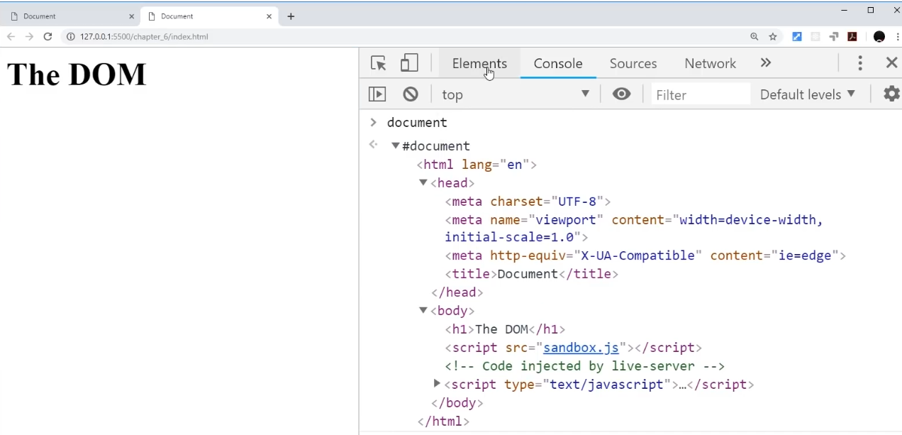

When you type document and press a dot (.) you can see all the properties related to the document object.

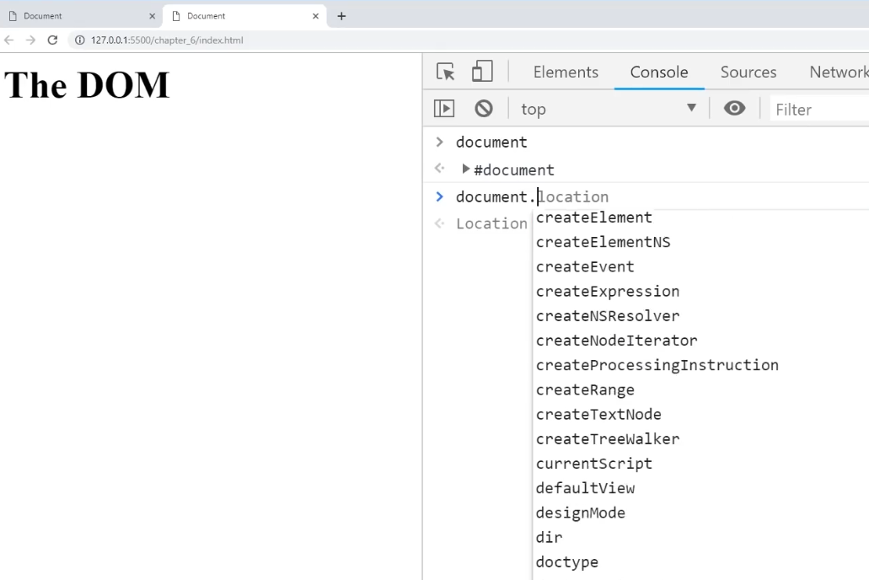

The DOM also describes how an object looks in a visual way too.

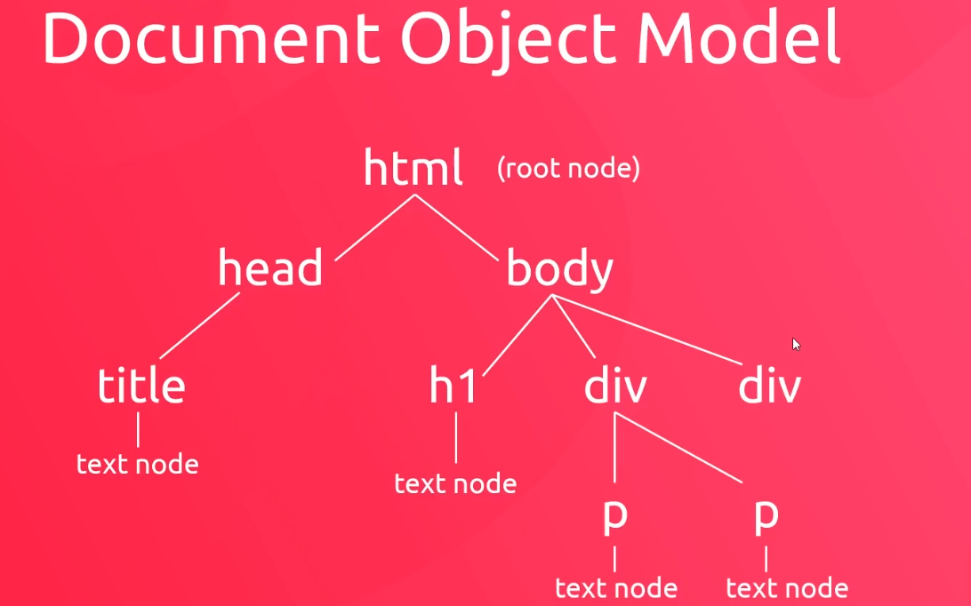

# Query Selector – Querying the DOM

We will now try to get access to the elements in this page.

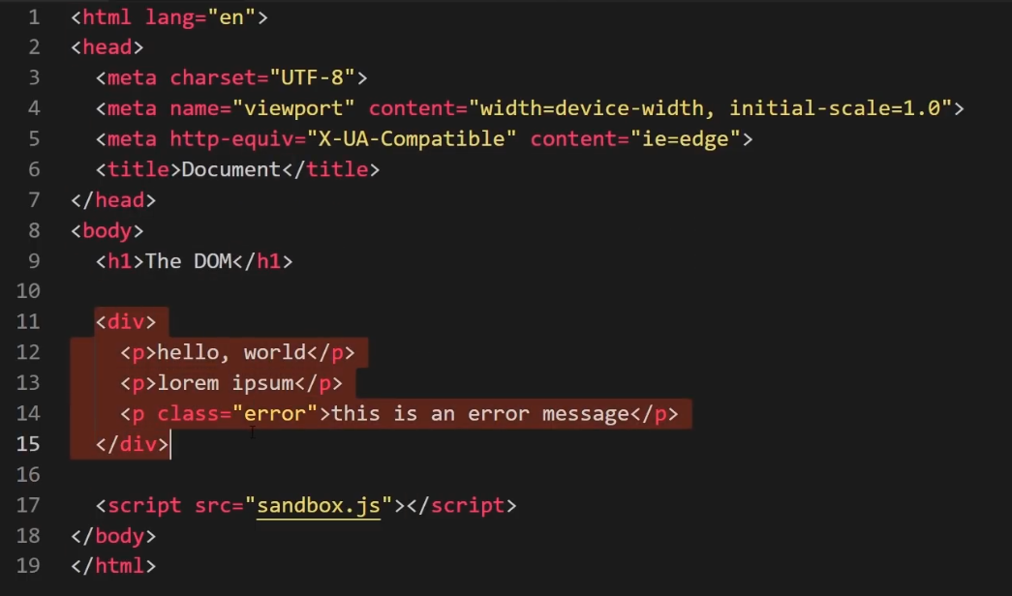

The way to query the DOM is through “**querySelector(‘**CSS selector’**)**” method on document object.

So when we write as below, we get the 1st “p” tag.

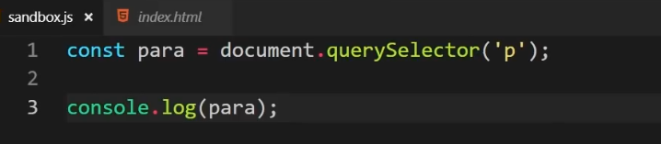

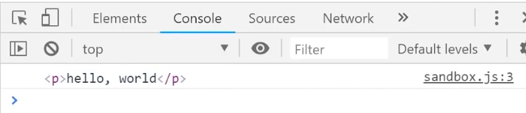

Now that we have the “p” tag in ‘para’, we can do a lot of things like change the content, style or delete the tag.

Now lets say we need to access the paragraph with class error. We do it like below as this is the only class we are using in the HTML file.

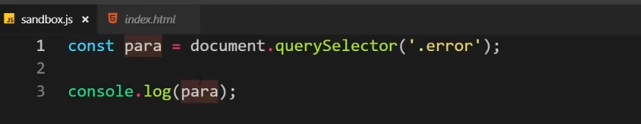

Now, lets say we need to grab the next paragraph with class. We can’t do it like above since it’s the 2nd paragraph with class tag.

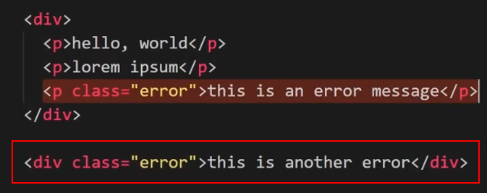

We do it like below

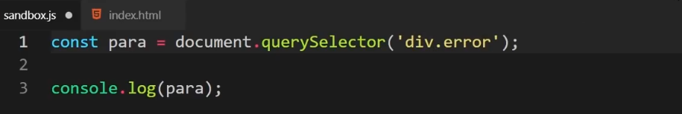

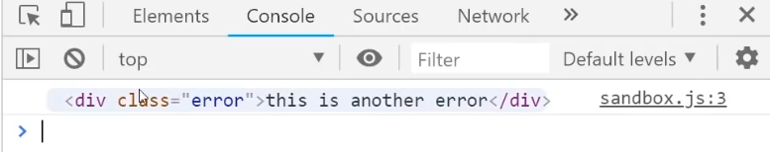

If you are not sure about the selector, you can take help of the browser.

* Right click the page and go to Inspect.
* Inside the elements tab, highlight the element you want a selector for. Right click it >> Copy>>Copy selector.

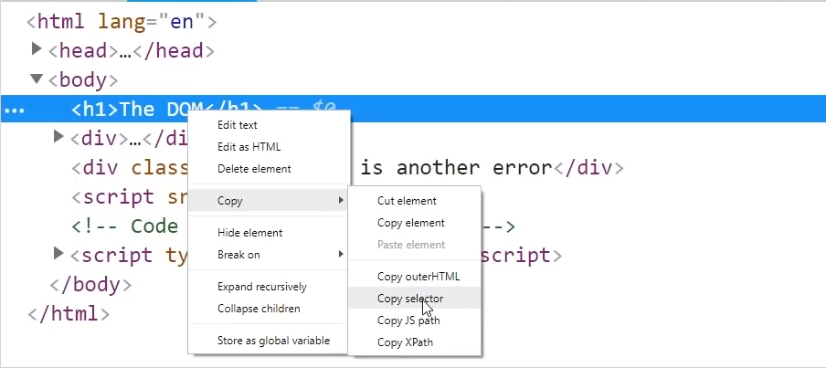

# Query Selector All

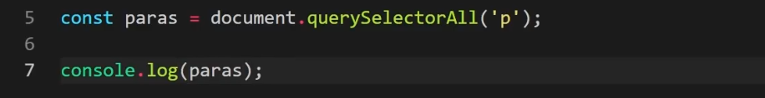

In the above code we are querying for all of the “p” tags in the HTML document and store them in a collection called ‘paras’.

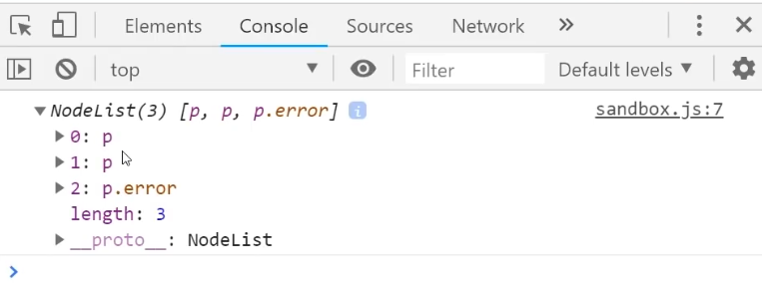

You can loop through this collection as a regular array.

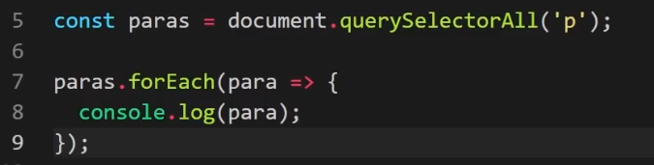

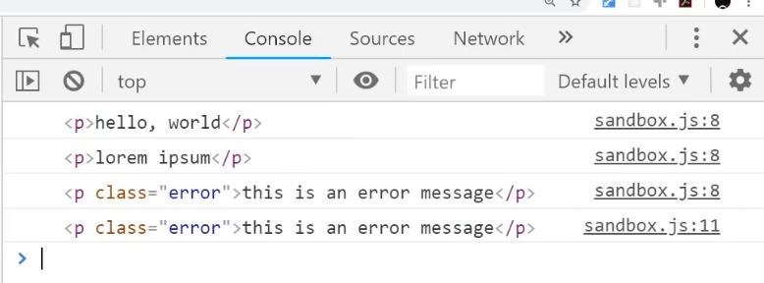

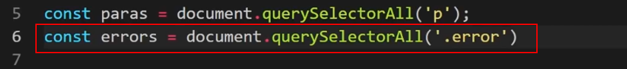

In the above code we are querying for all the tags for error class.

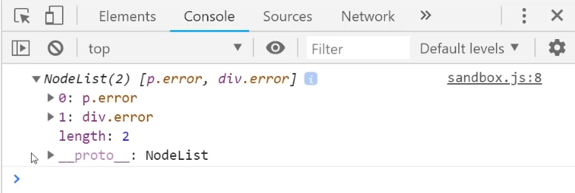

# Getting element by ID

In an HTML document, we should have unique name for each “**Id**”. By using the name of the Id, we can get the element’s reference.

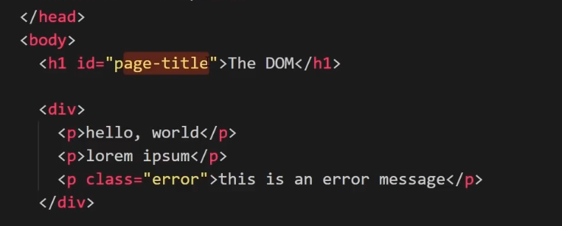

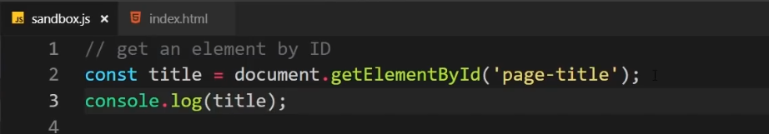

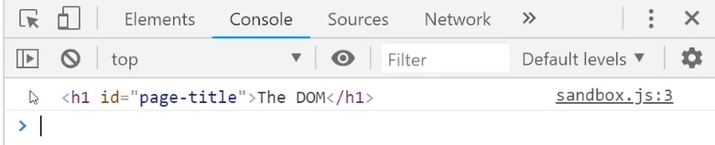

# Getting elements by Class Name

Using the above method, we get the elements by id. Note that we get reference to only one element using this method.

Note the different in method name using class name. It refers to as “elements” instead of “element”. This is because you get multiple elements of the same class using this method.

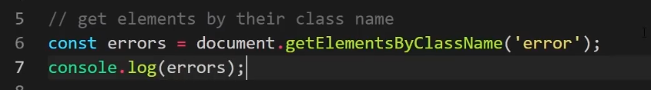

Here we get an **HTMLCollection**. Note that we got a similar collection called **NodeList** using querySelectorAll(). We can access individual elements in this collection as in an array but we cannot use a foreach function.

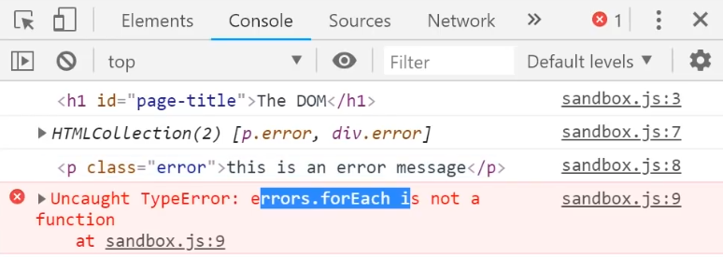

# Getting element by Tag Name

In the below code we are querying for all the elements by tag name. We will get all the paragraph tags that will be stored in “paras” which is a **HTMLCollection**.

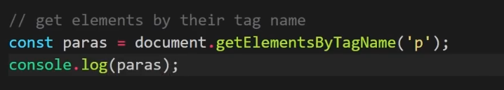

# Changing text inside element

How do we get access to the text inside an element? We do this by using the property “innerText”. Note that this is a property and not a method.

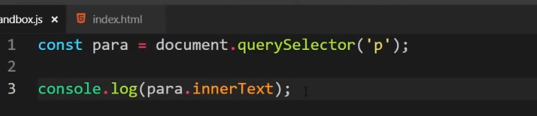

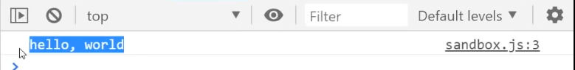

We can easily modify the contents like below.

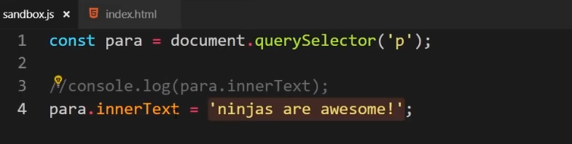

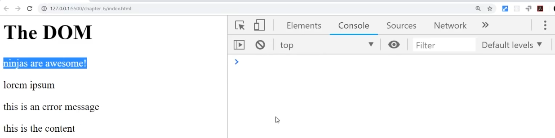

In the below code, we will add some new text in each element of “p” tag.

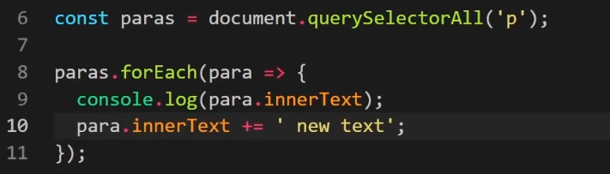

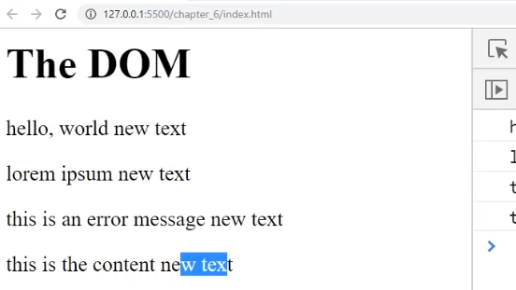

# Changing HTML inside element

How do we change the HTML inside the tag? In the below HTML we want to change the HTML inside “div” tag.

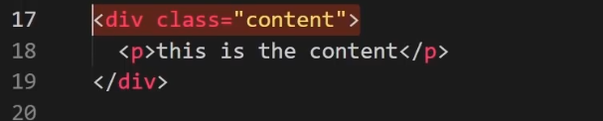

1st we need to get the access to the div class HTML. We do so using below.

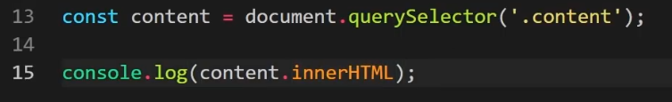

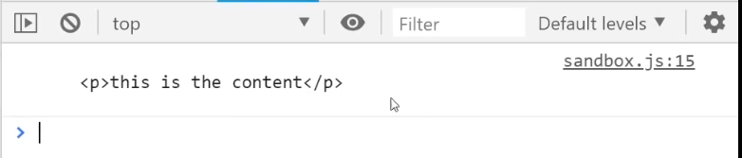

Now we change the HTML that was inside the content class.

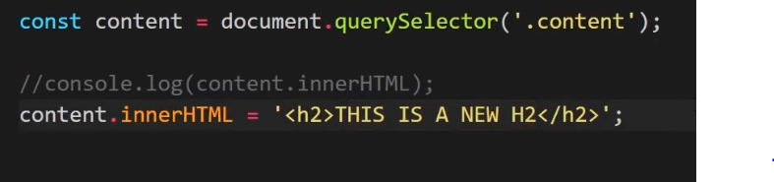

And as we see below, we have a new heading inside the content class.

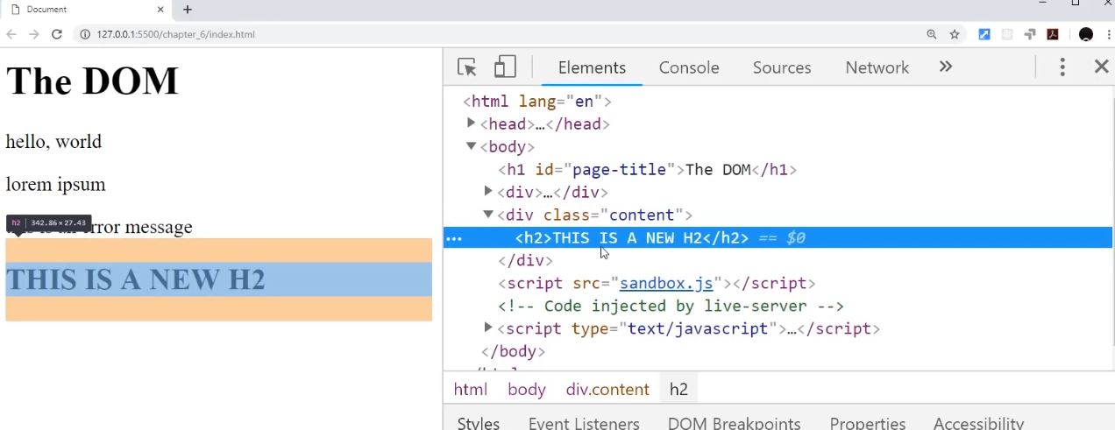

Now we will look at a scenario where we assume that we got a list of people and stored them in an array. Now we will cycle trough these people and output each of them in HMTL.

We will create an HTML template inside the callback function. We will take the “content” from above and append each person to this content.

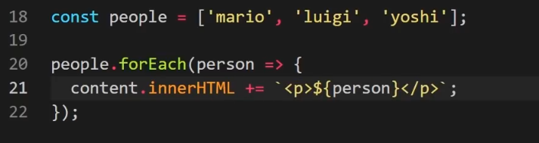

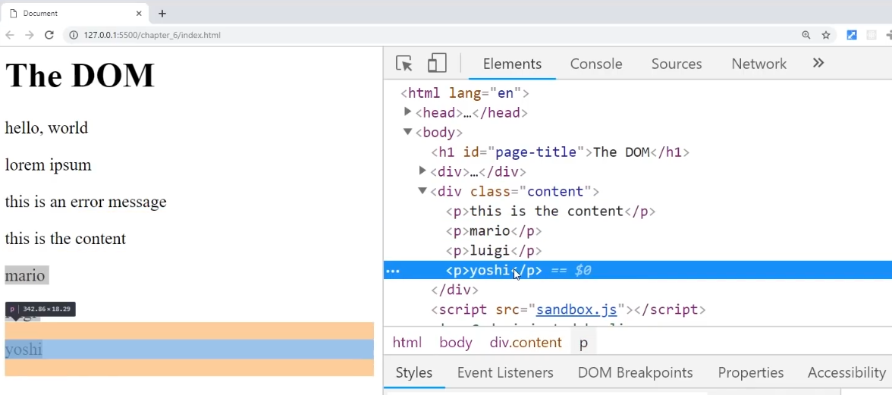

# Getting and setting attribute of element

What are HTML attributes? In the below screenshot, **href** and **class** are HTML attributes.

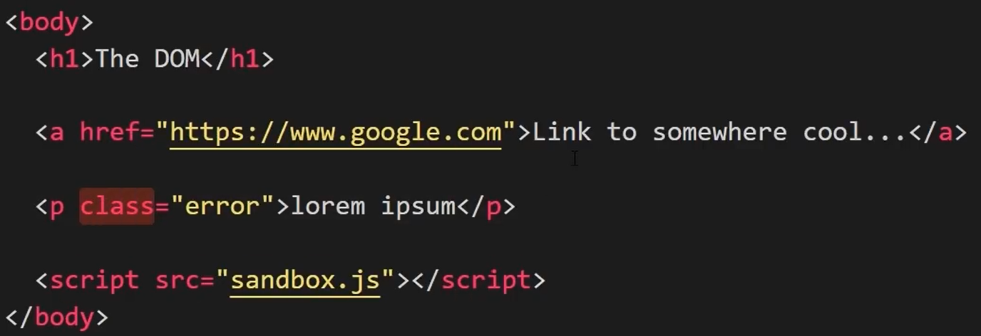

Now lets take a look how we can change these HTML attributes.

1st of all we need to get the reference of the element that we want to change. Then we can extract the attribute by using the **getAttribute** method.

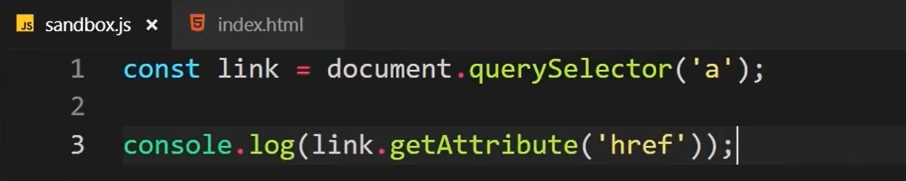

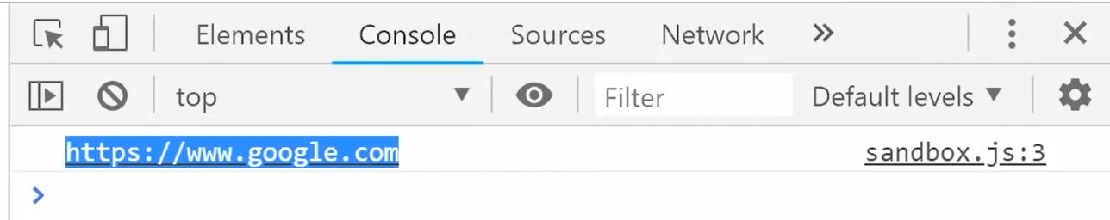

We can also set attribute by using another method like below.

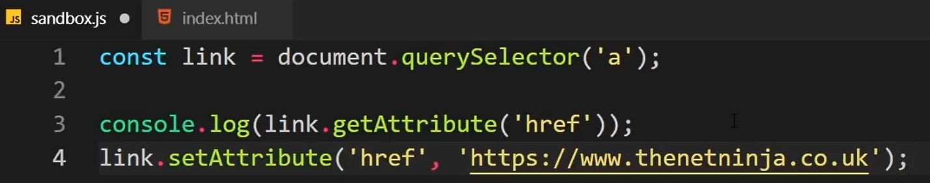

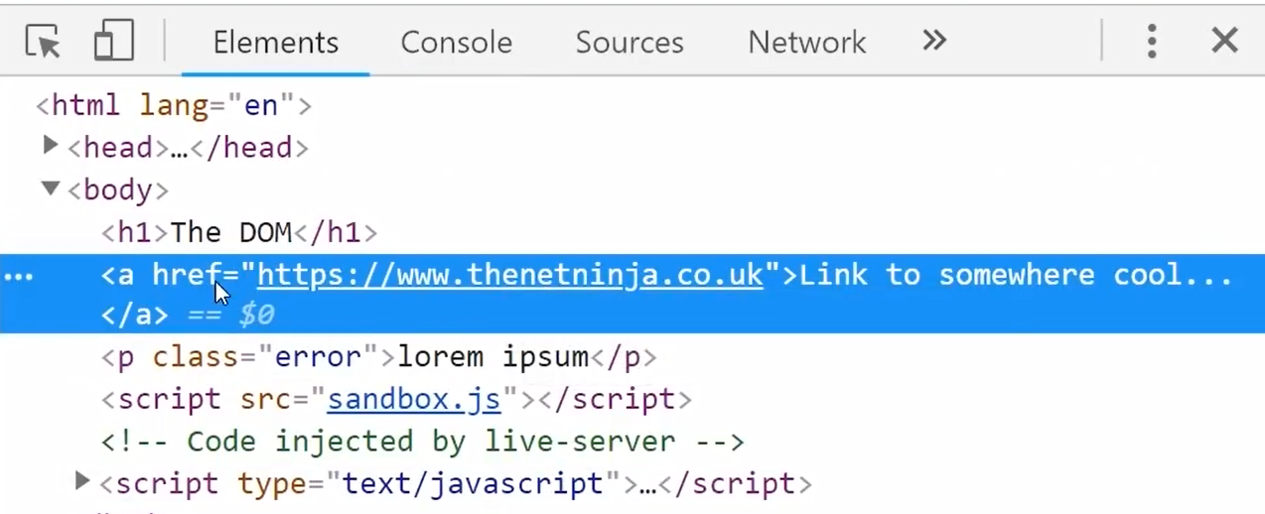

Similar to the above, we will now change the attribute class.

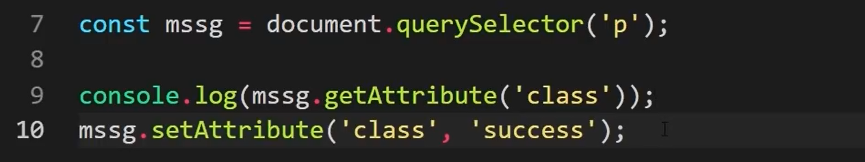

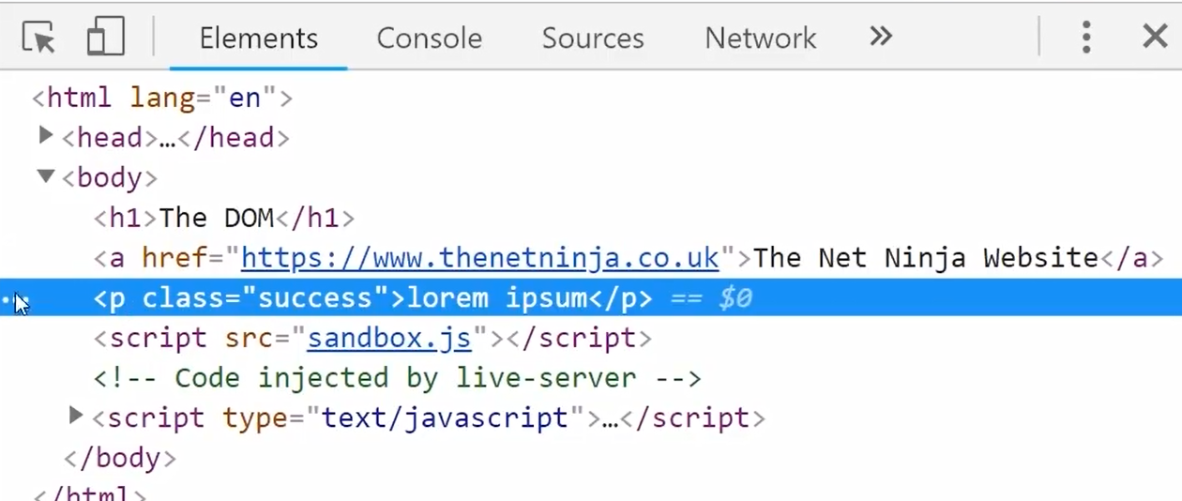

This is how we can change the **class** attribute value to either error or success and the CSS will be applied according to the value.

We can also set an attribute which does not even exist. In the below code we are setting a style attribute with color:green.

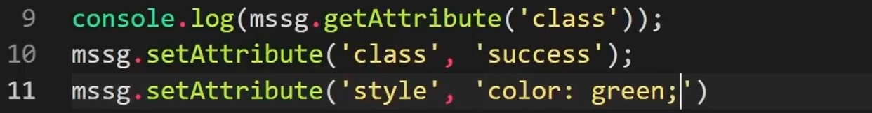

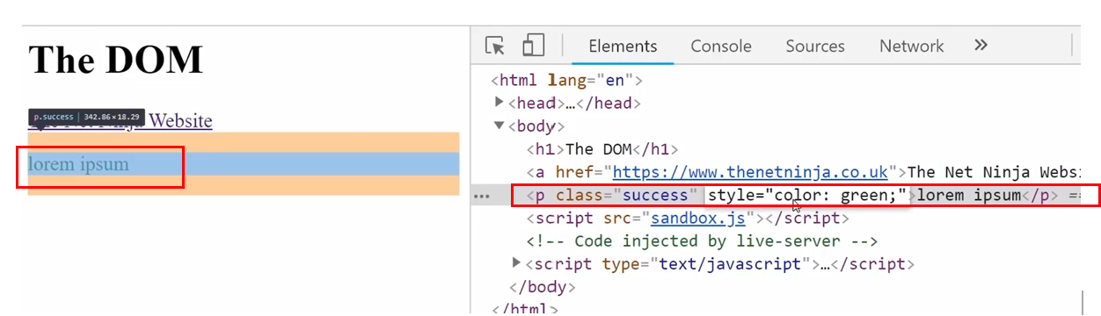

Remember that when we are setting the style value as above, it will completely override the existing style that is used in the HTML document. In order to add styles rather than overriding them, we can use the style **property**.

In the below code, we are logging the style property in the console. As you can see, we get every possible CSS property. Out of these, the color property is set to “orange” while most of the other properties are empty.

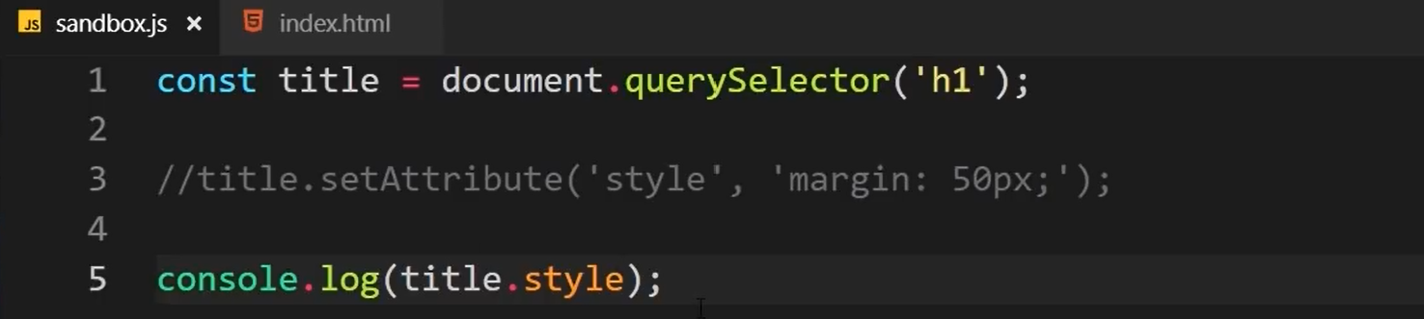

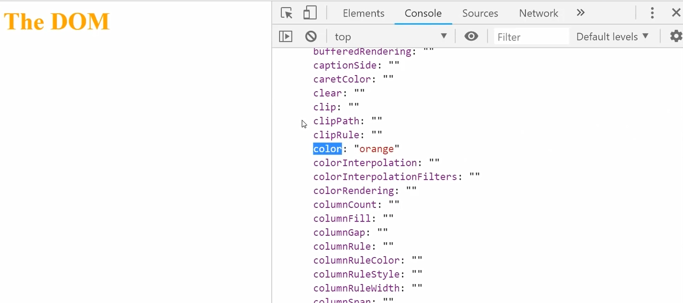

We can set this style property to add CSS styles on the fly or even remove them. When we log the color property to the console, we get “orange”.

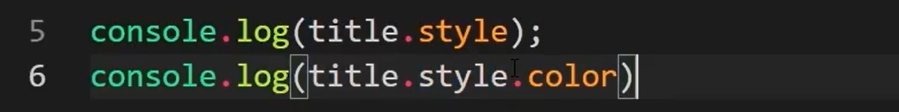

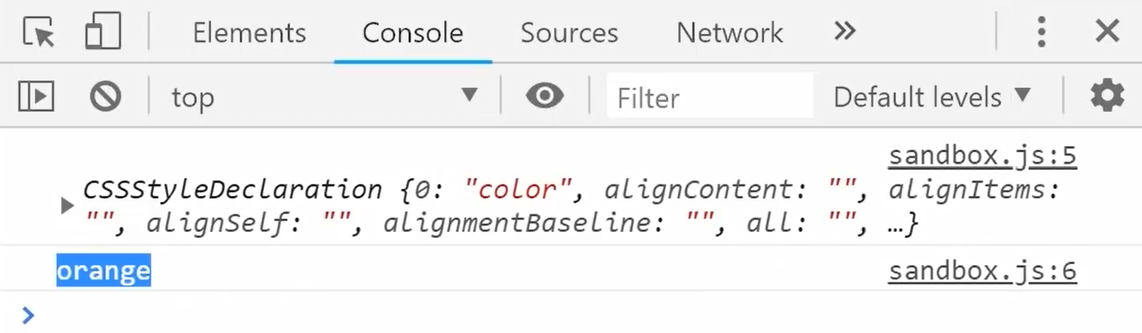

Now, we will add additional style to our heading tag. The margin property is added to the style rather than being overriden.

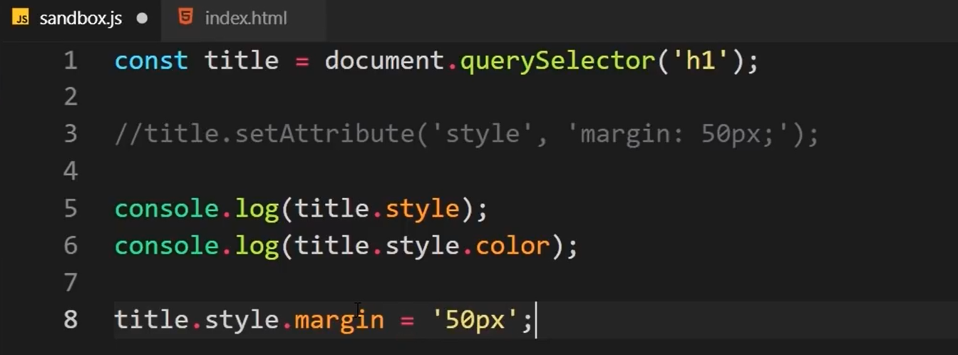

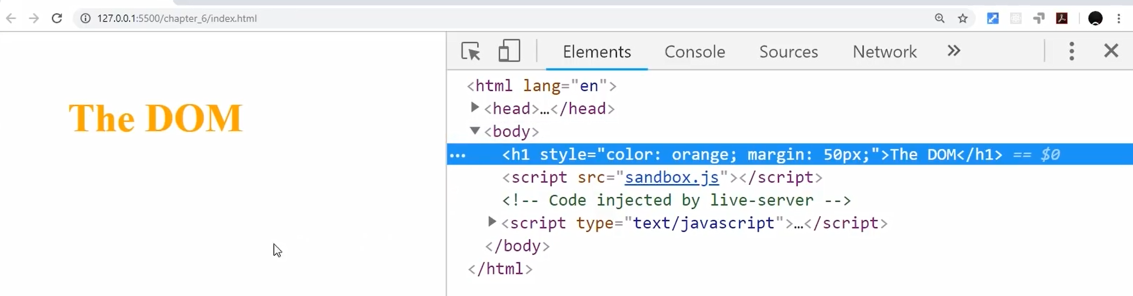

We can similarly add or update as many CSS properties as we like. Below we are changing the color property to crimson and adding properties margin and font-size.

Note that in Javascript, we have to use – separated properties like **font-size** in camel case as **fontSize**. This is because Javascript will treats font-size as something like “font minus size”.

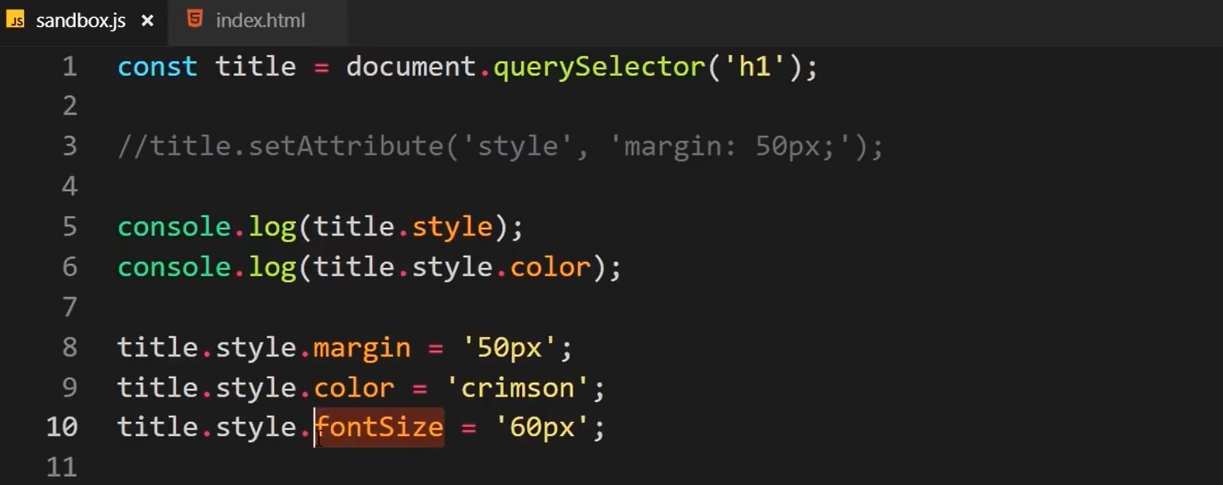

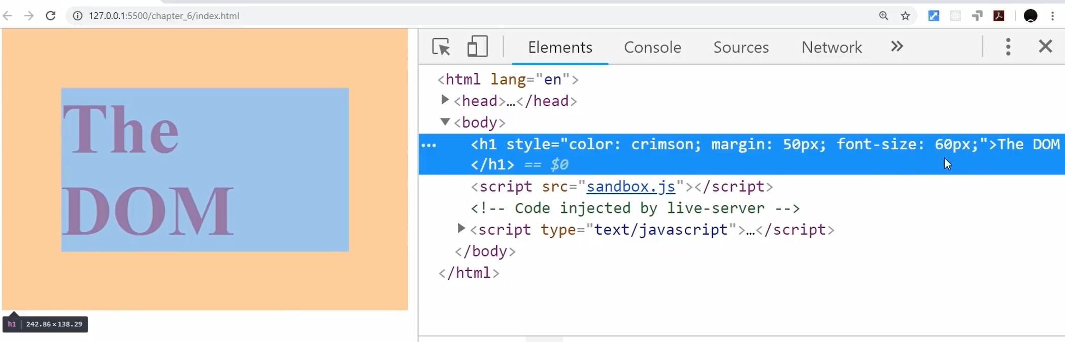

To remove the property, simply set the property name as empty.



# Adding and removing class

For our example, we have a paragraph with class called “error” and we have two classes called success and error as defined below.

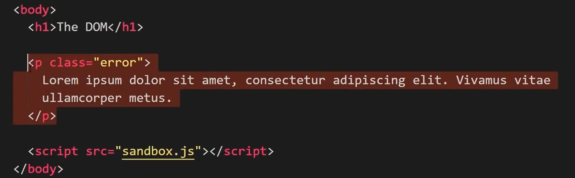

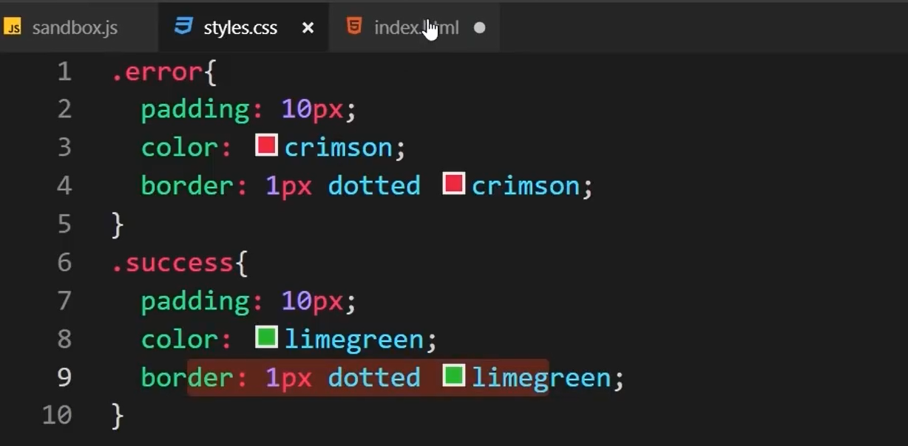

We will now change the class from error to success at runtime.

The **classList** property lists all the classes applied to a particular tag. In the below code, we have listed all the classes (not used actually but just displayed for eg.)

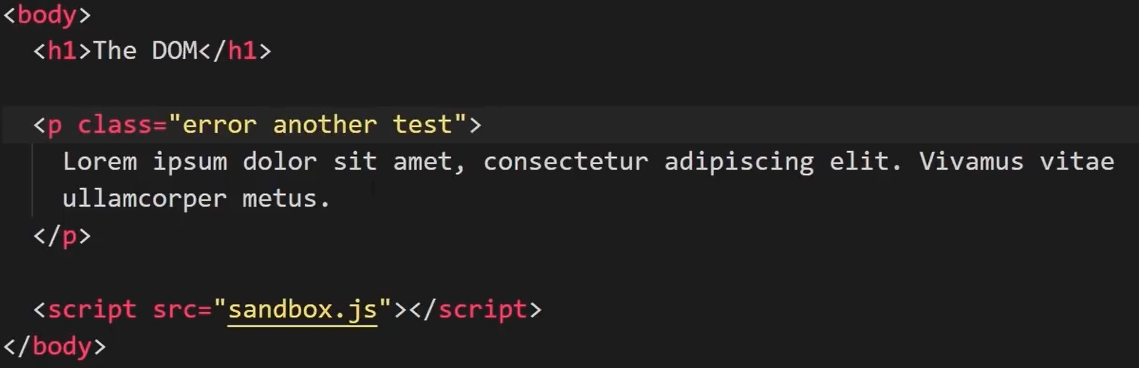

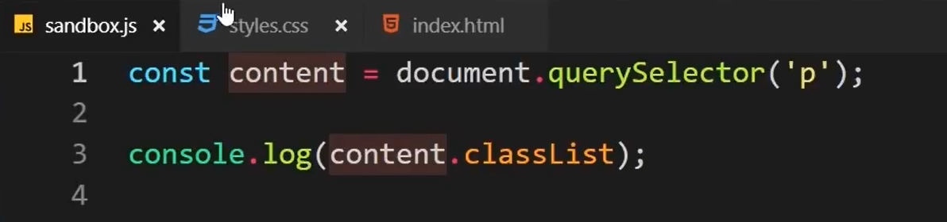

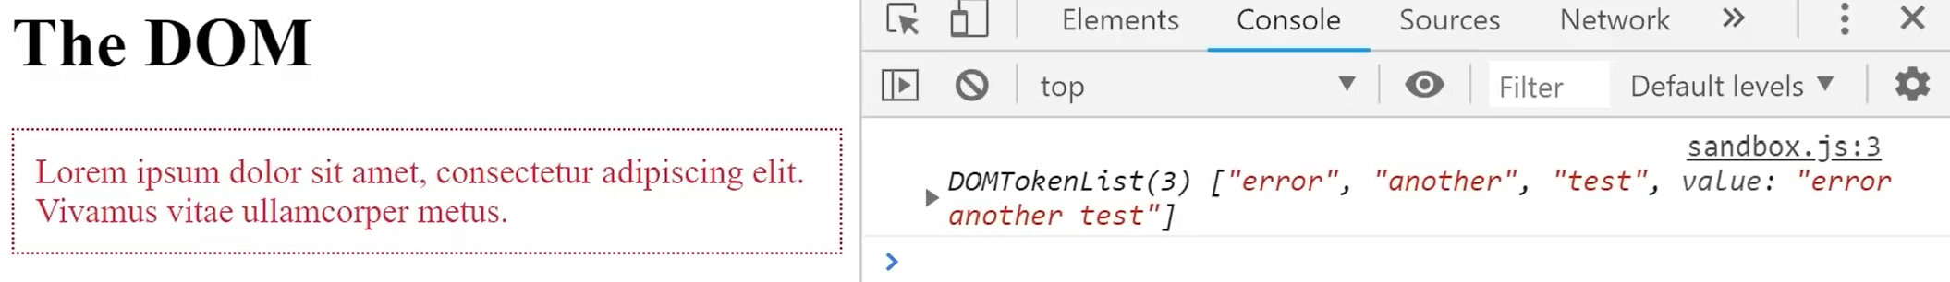

Now, we can add or remove the classes using below code.

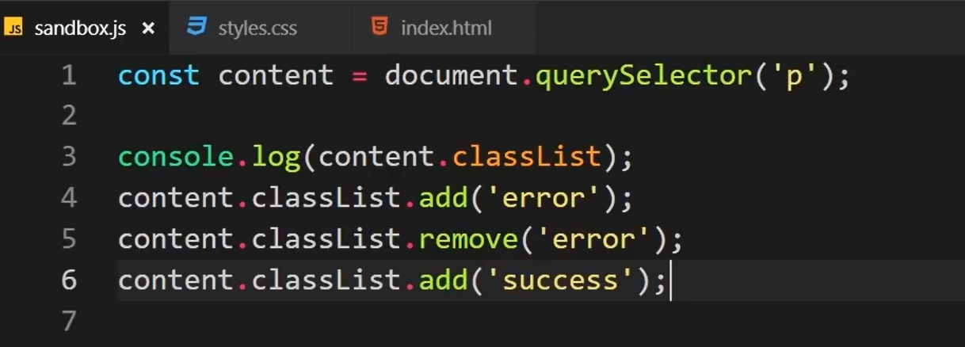

# Challenge

# Toggling class

# What is Async JavaScript

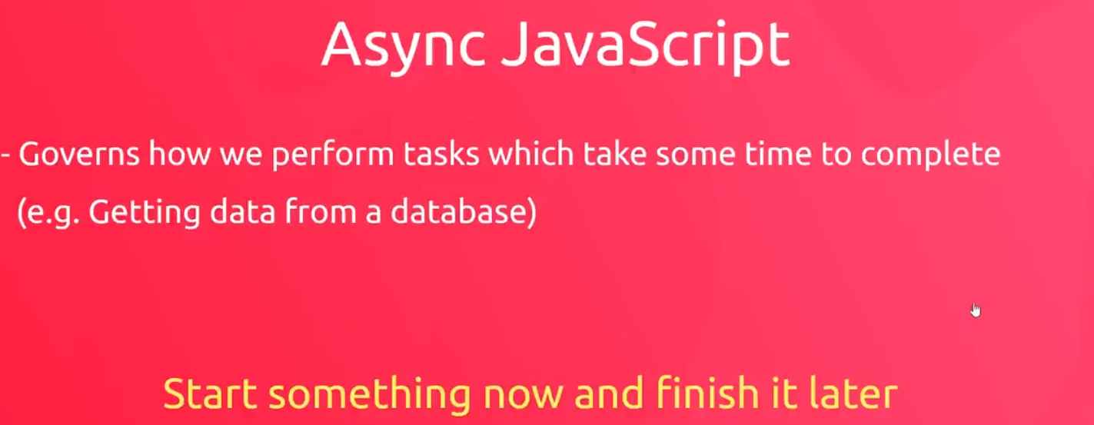

By default, Javascript is synchronous.

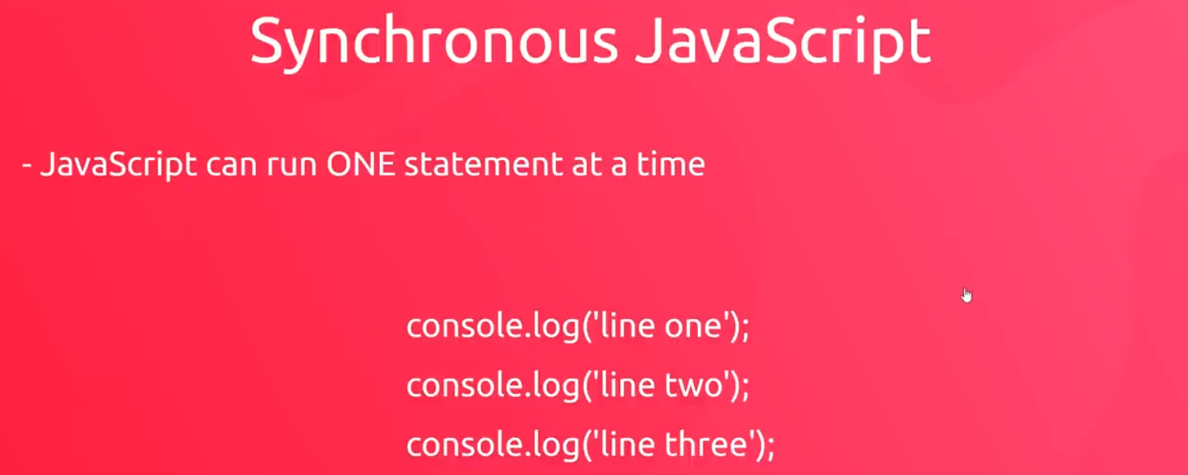

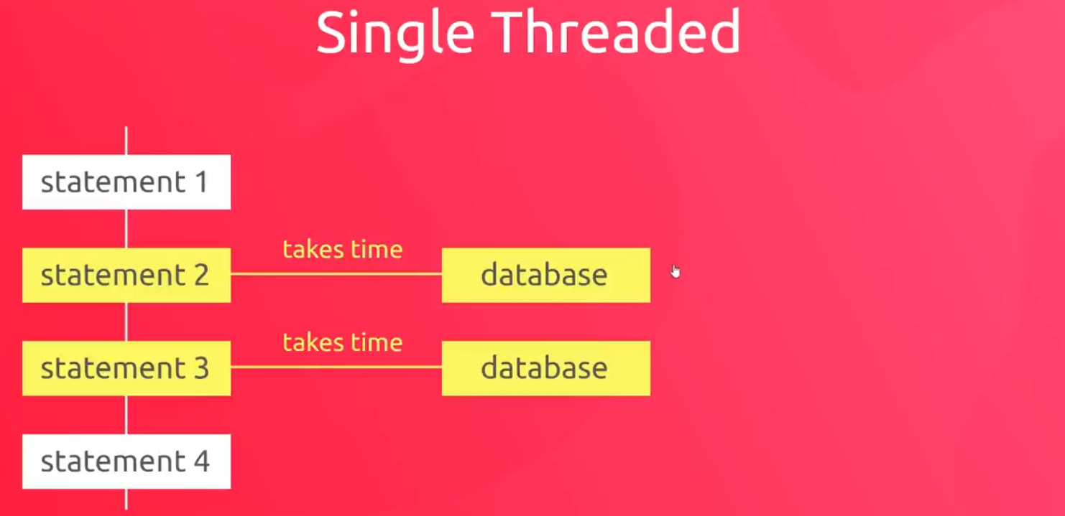

Using async Javascript, we pass a “callback function” as a parameter to the statement (or function) which is taking time. The callback function runs and finishes later once the data comes back from the database. It does not block the other statements from running.

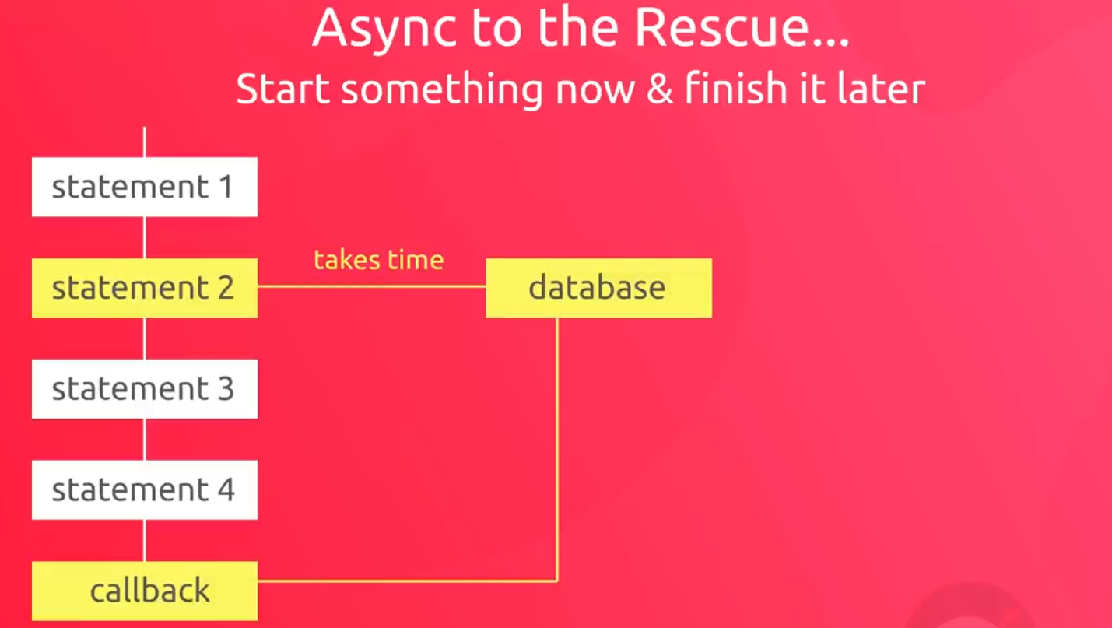

Below we are emulating a network call by setting up a timeout.

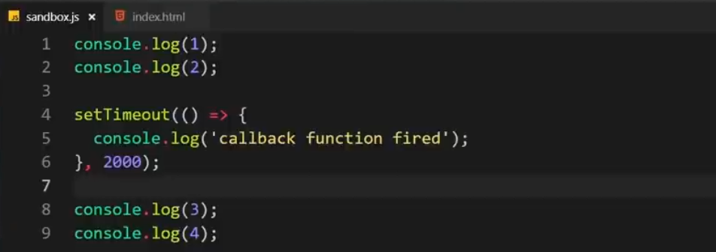

As we can see, the setTimeout() function is executed at last (after 2 seconds or 2000 ms). The function does not block the execution of other statements. This is similar to the HTTP requests that we will make later.

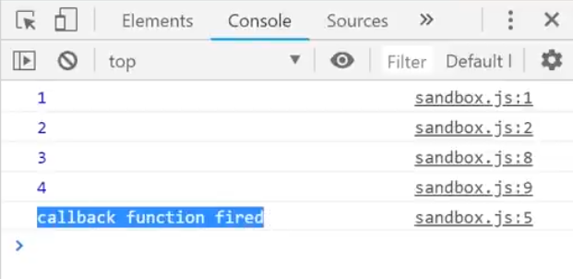

# HTTP Requests

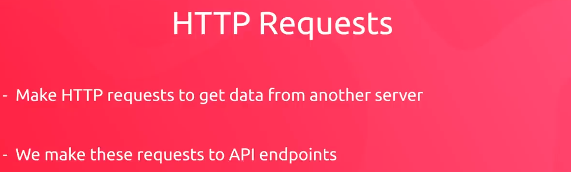

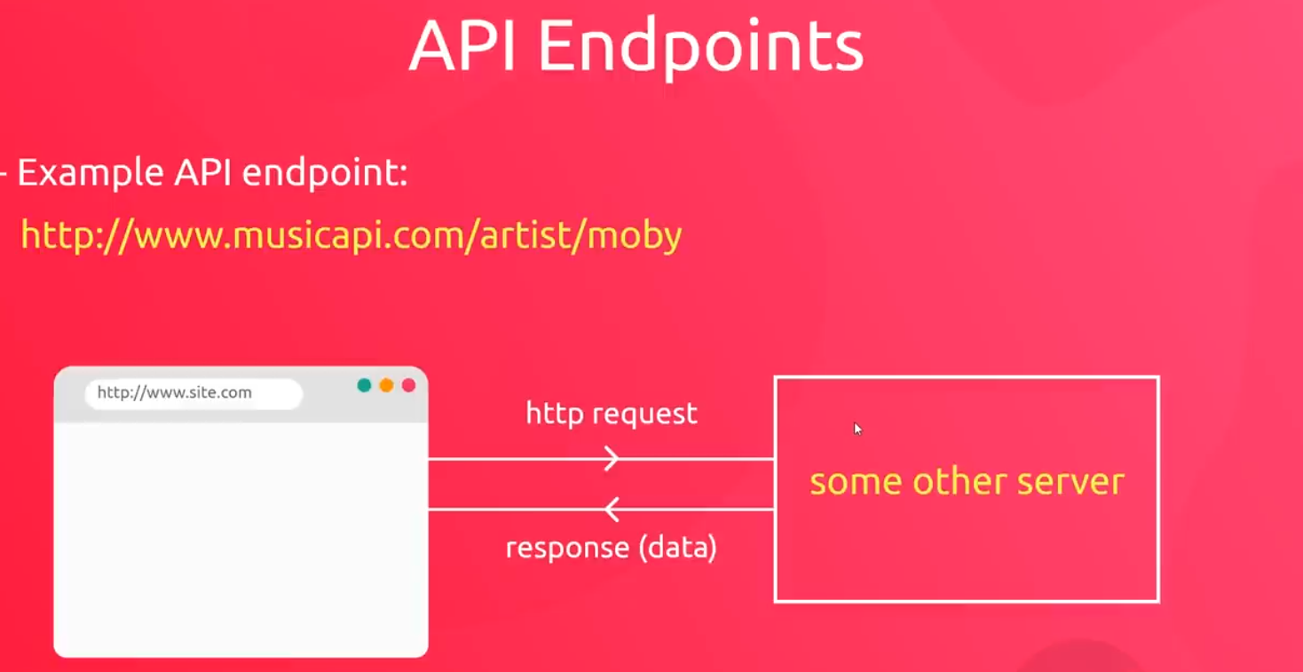

We will use a website called “JSON Placeholder” to place an API call.

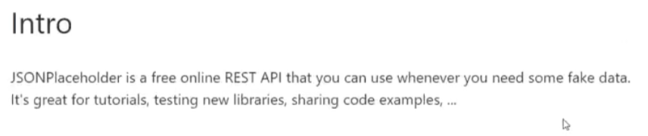

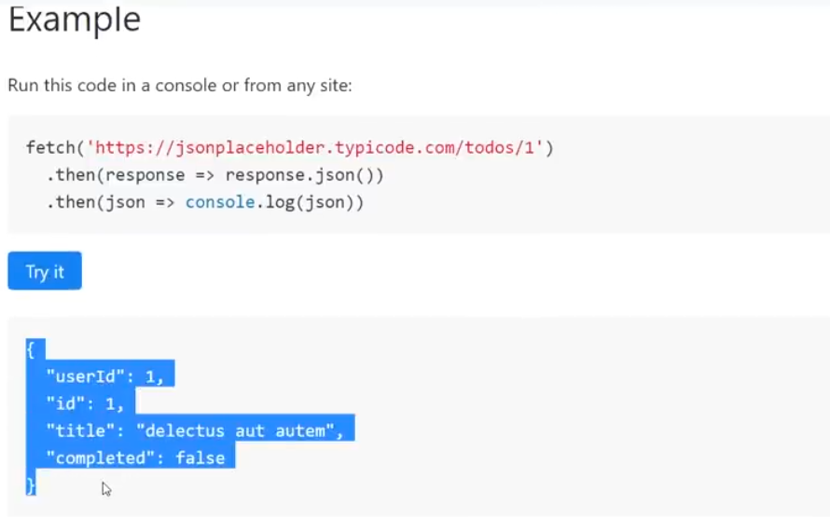

We can make the same request directly from our browser. If we navigate to the “Network” tab we see the details of the network request.

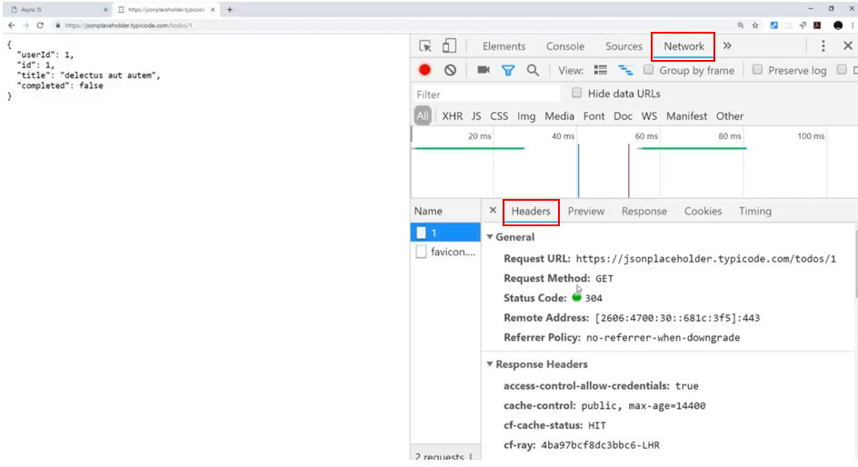

Similarly, navigating to the “Response” tab, we get the response received from the API.

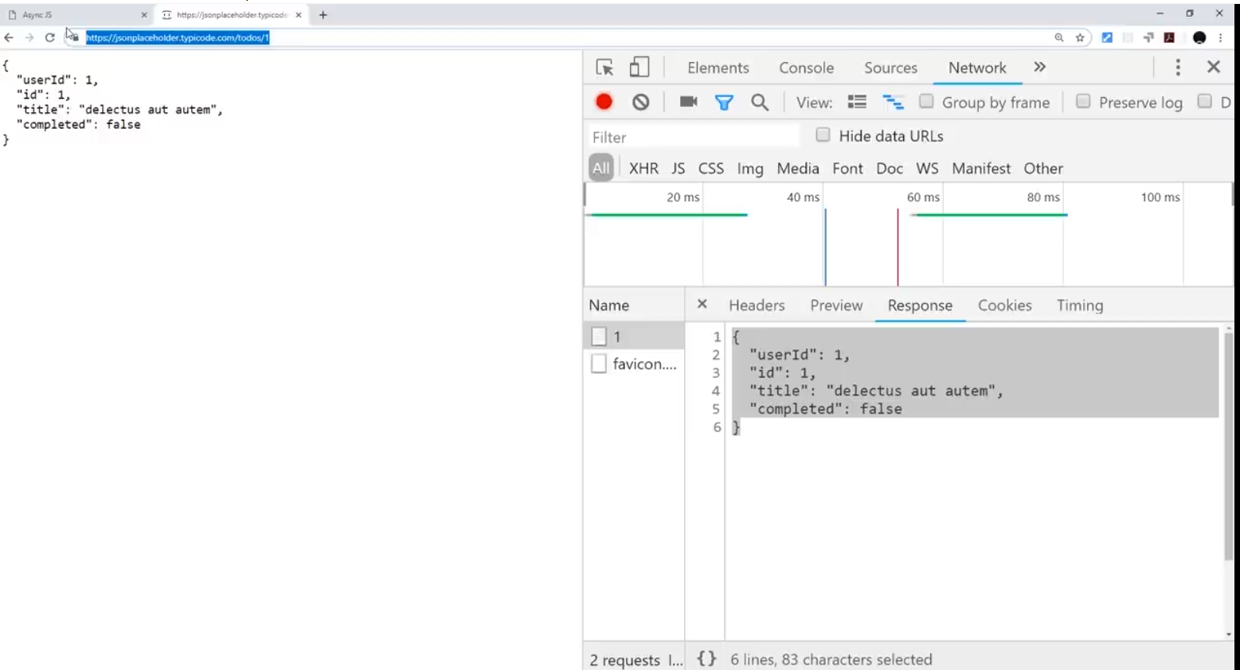

Now we will use this REST endpoint in our javascript code. Below we will build the request object to fetch the data. Note the use of “**XMLHttpRequest()**” function to create a request object. XML format was used much earlier before the JSON was created. Using this function, you can fetch data in any kind of format i.e. XML, JSON or plain text.

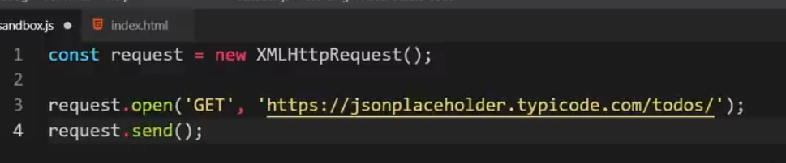

request.open() => Takes 2 parameters. Used to specify the end point and the HTTP method to use. Note that we are fetching all the “todos” here.

request.send => Used to send the request.

Now when we open this HTML page (index.html), we can see the web service call in the Network tab.

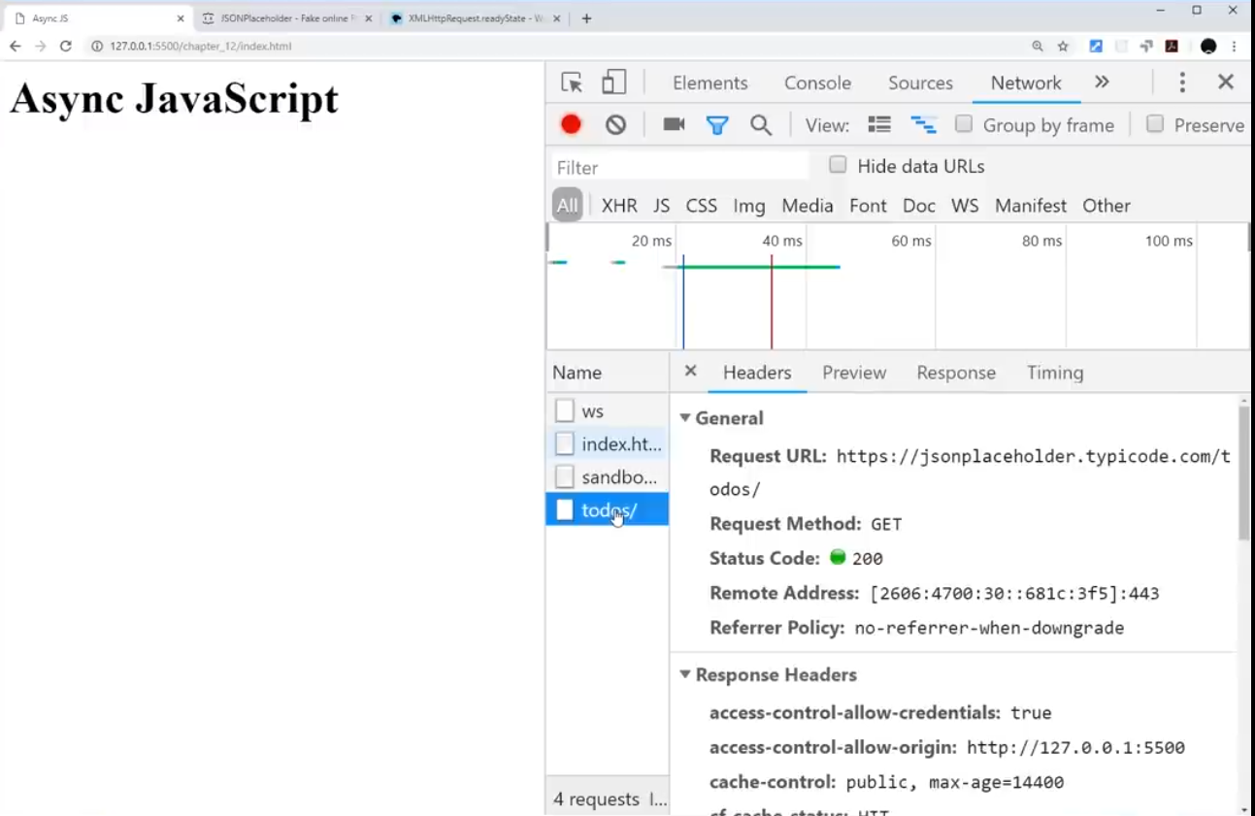

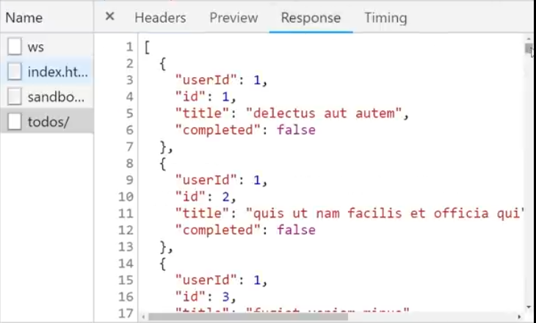

As of now, we do not know how to track the progress of this network request in our code. We can do it using an **event listener** and a specific event called “readystatechange”

What’s going to happen now is that we are going to setup a request and send it. And then every time there is some kind of ‘readystatechange’ its going to log it in console.

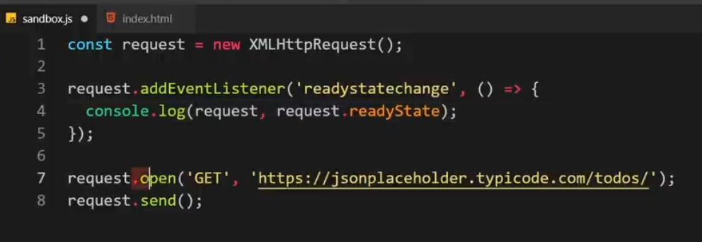

When we open the console we see 4 states logged into the console.

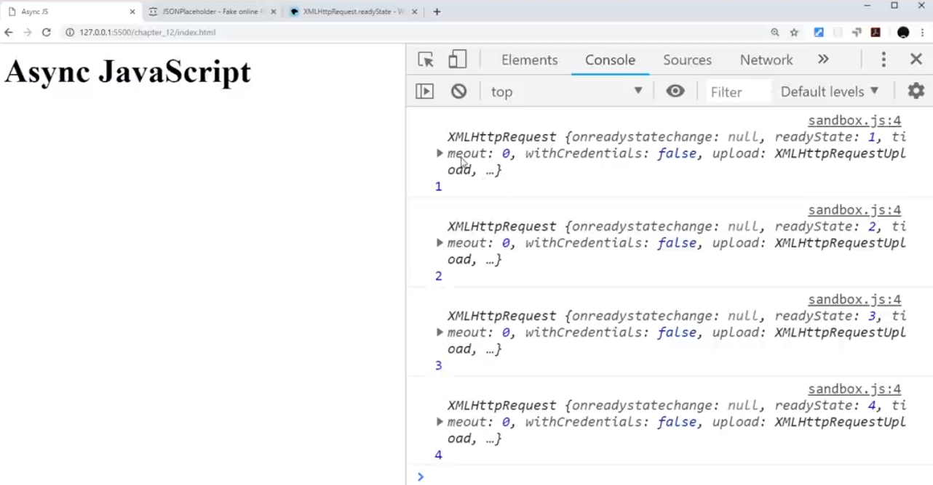

What does these states mean?

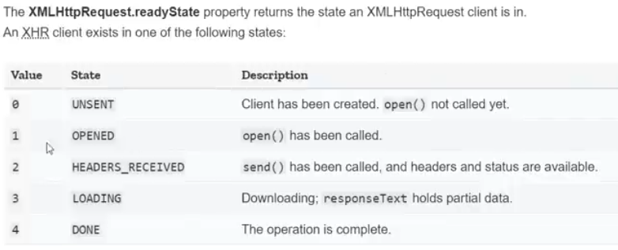

When we expand the readystate 4 in our console, we see it like above. As you can see, the responseText is present in this. Also, the status is ‘200’ which means “success”.

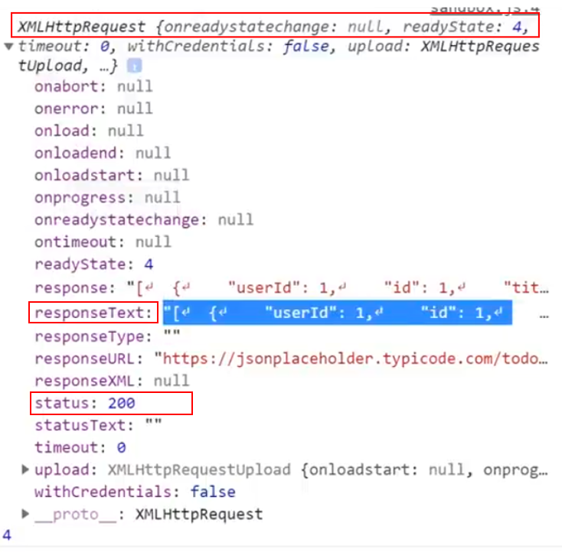

Now, we can modify our function to retrieve the response from our request and log in into the console.

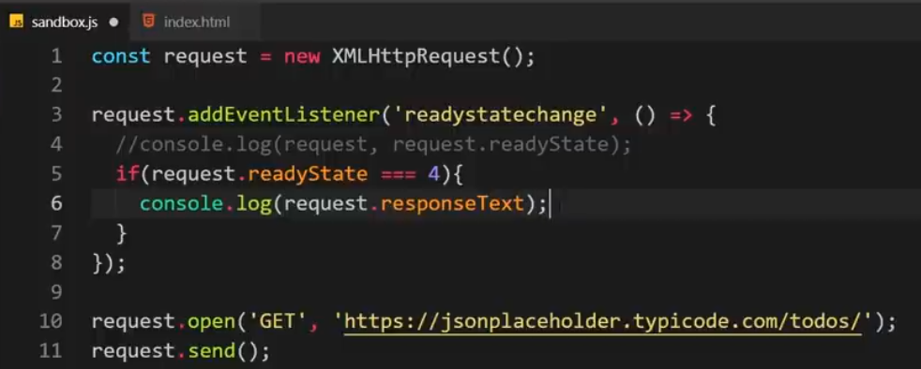

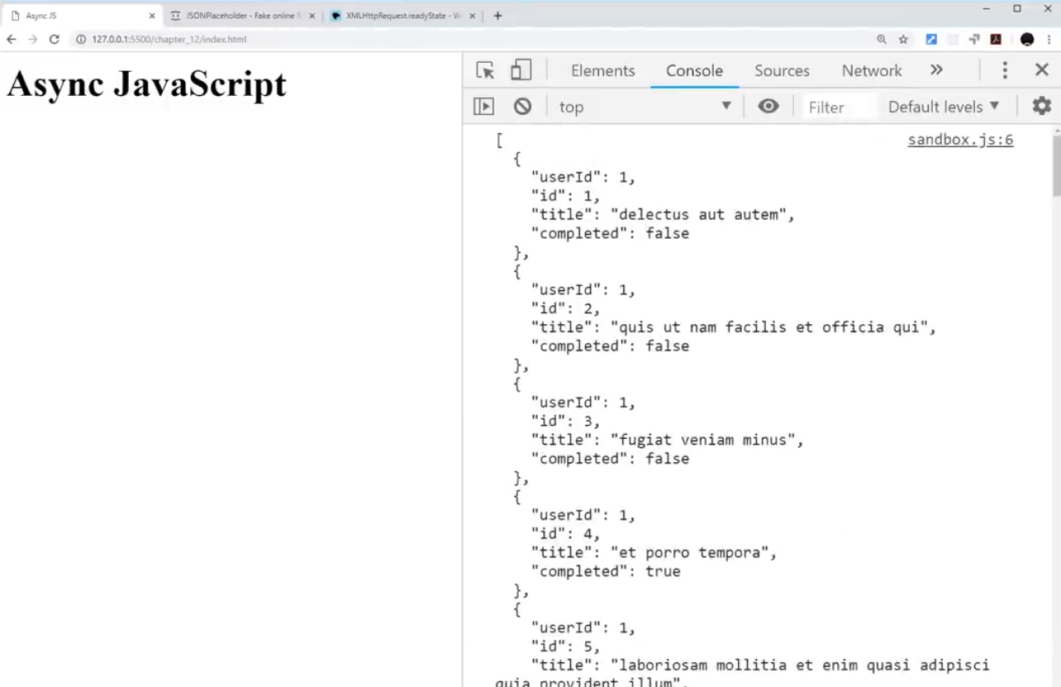

# Status Codes

When we try to fetch the data from an endpoint, we might get an error. Below we have changed the URL of the endpoint to include an extra ‘s’.

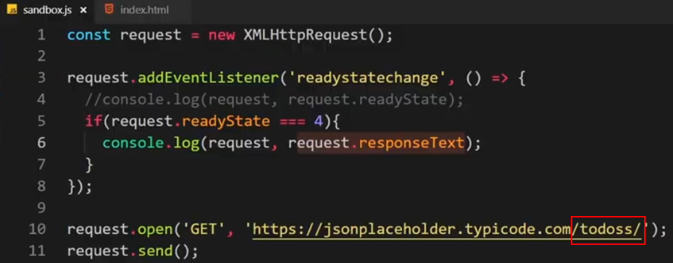

When we see the console, we get an error message.

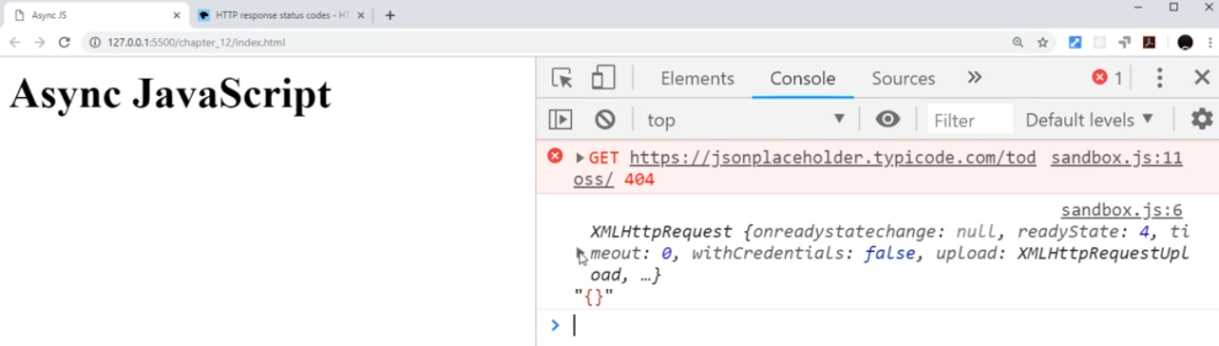

When we expand the readystate 4, we see that the resposeText is empty and the status is “404”.

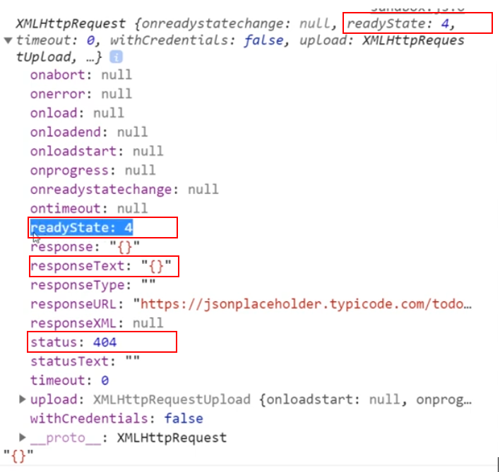

Below is the list of some of the most common HTTP status codes.

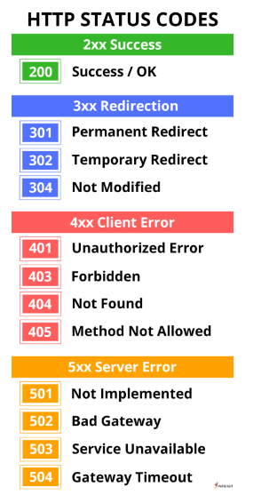

Now, we will also test for the status code in our function and log the HTTP response only when we get a successful response. Otherwise, we log an error message.

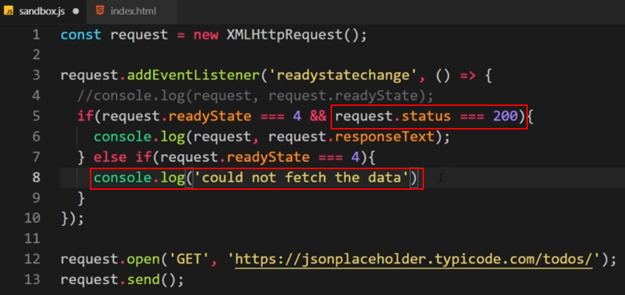

So when we get a 404 error, we do not log anything into the console.

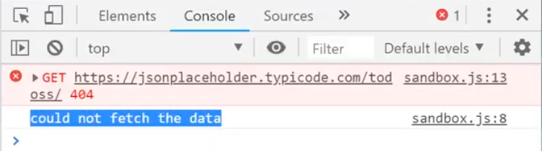

# Callback Functions

In the below code, we have created a getTodos() function which takes a callback function as a parameter. We then call getTodos() by passing a callback function as an argument and then fire it based upon the response we get for our request i.e. either a success or an error.

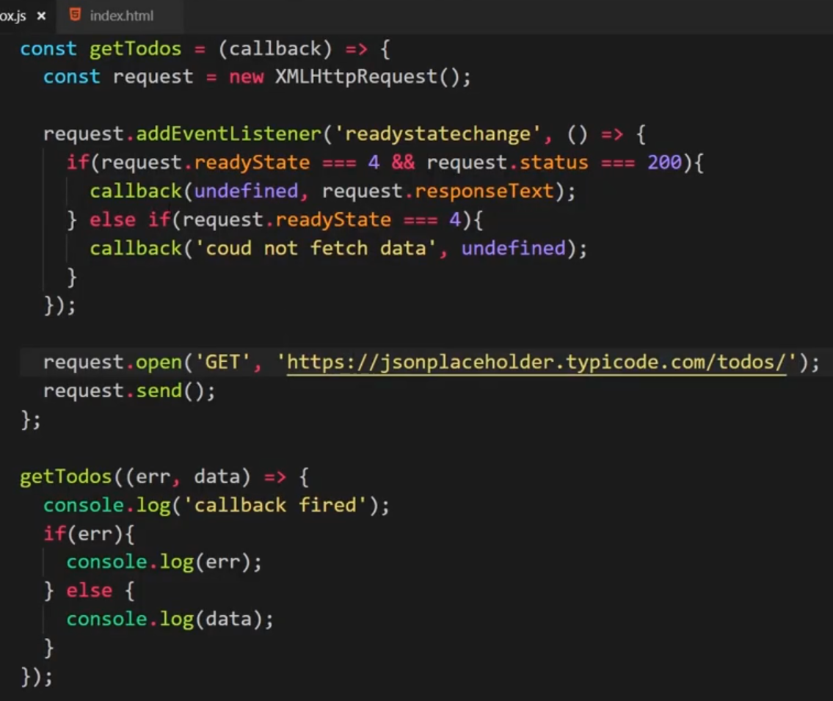

Next we will apply this in the async javascript perspective to demonstrate async code. We place few console.log() statements around the getTodos() function and check for the execution sequence.

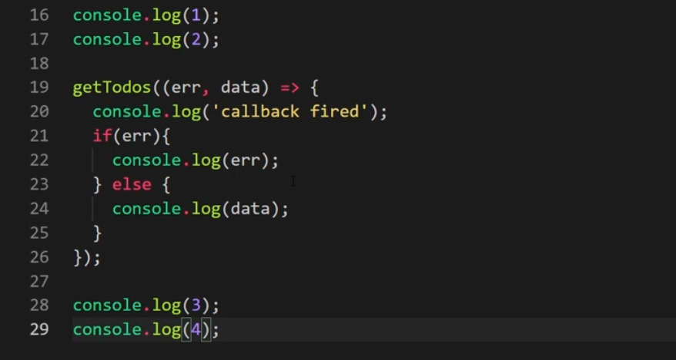

When we save and run this we see output as follows. All the console.log() statements fired first and then the getTodos() function got executed.

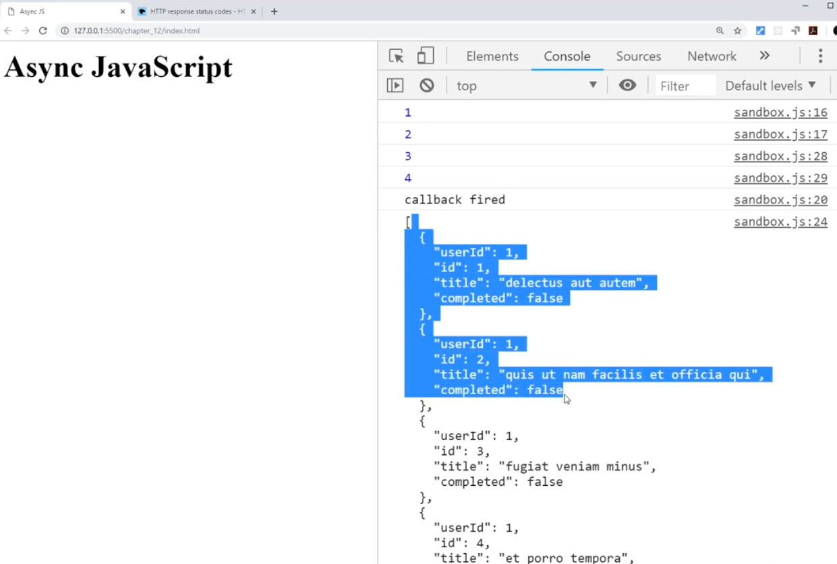

# Using JSON Data

JSON is a format used by the server and client (browser) to transfer the data between them. JSON looks like an array of Javascript objects but it is just a string. The string is formatted in a way that looks like javascript objects with curly braces and key value pair.

So, in short, JSON is a string which looks like javascript objects.

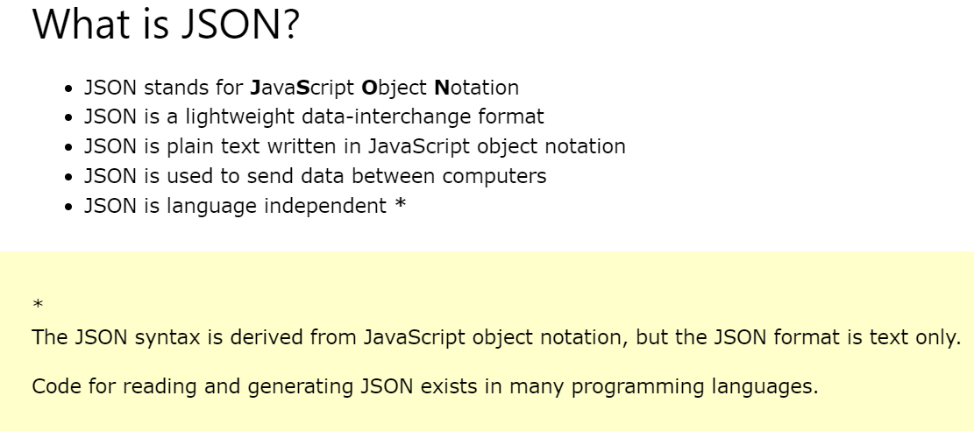

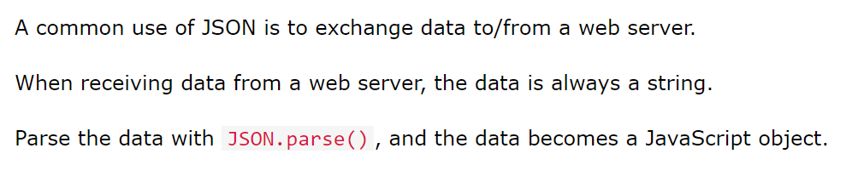

We will now use JSON.parse() in our getTodos() function to convert the response to Javascript object and log them in console. We can cycle through the array and access individual objects.

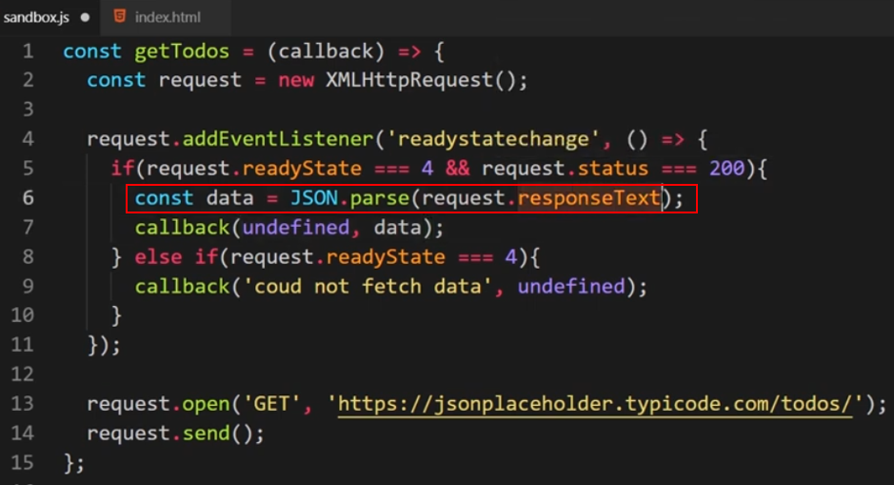

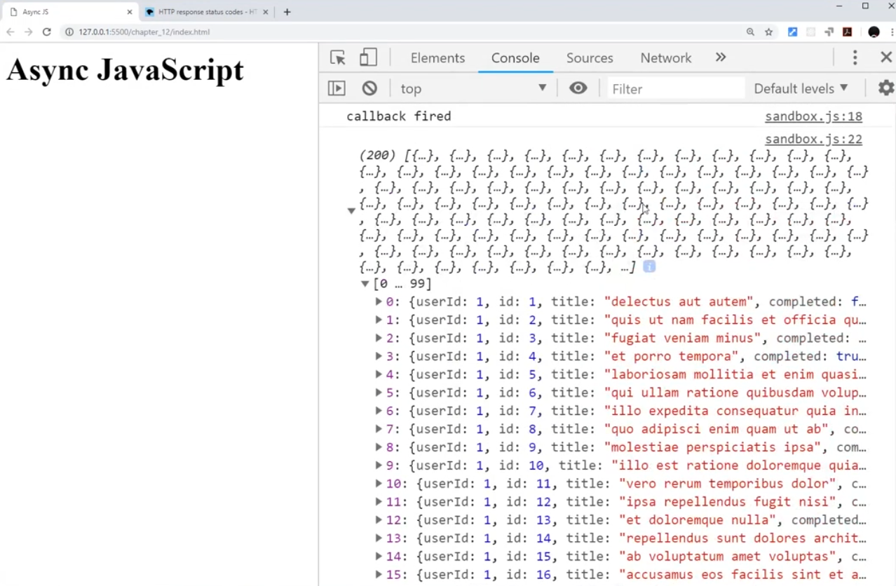

# Callback Hell

# Promises

# Chaining Promises

# The Fetch API

# Async & Await

# Throwing Errors